Parallelism

Definition
# Source: AI Source: Provided by: [Data Path: Persons Table -> ID Column: 1, Name_En Column: Motasem Essam] -> From: [ChatGPT] on [7/25/2026]
Parallelism is a geometric relationship in which two or more lines, line segments, or other geometric objects maintain a constant distance from each other and do not intersect, even when extended indefinitely in the same plane.
For two distinct lines $l_{1}$ and $l_{2}$:
$$\boxed{l_{1}∥l_{2}}$$
This is read as:
“Line $l_{1}$ is parallel to line $l_{2}$.”
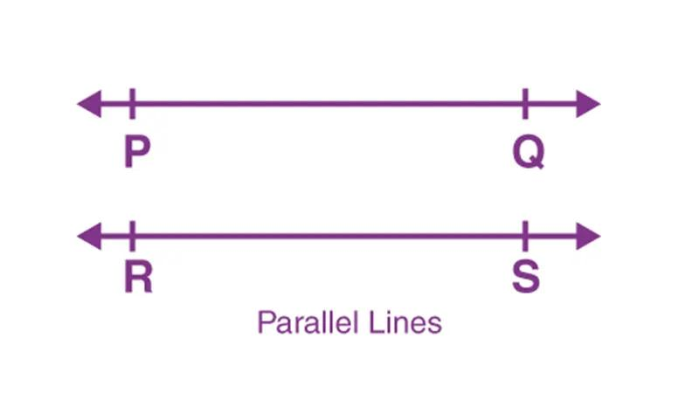
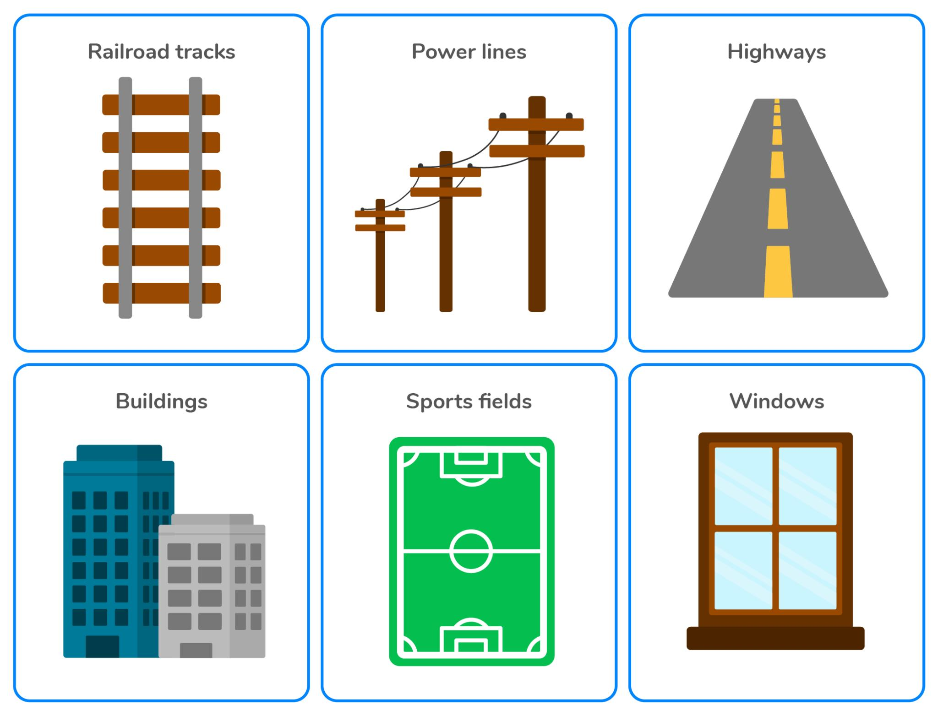
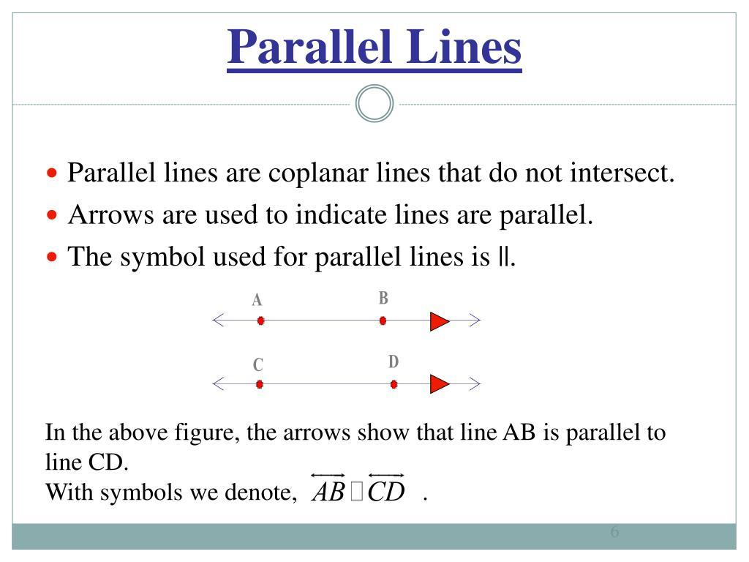
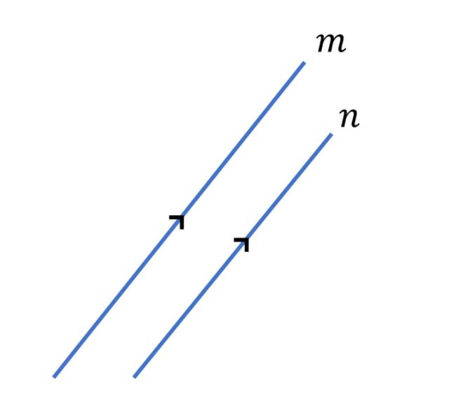
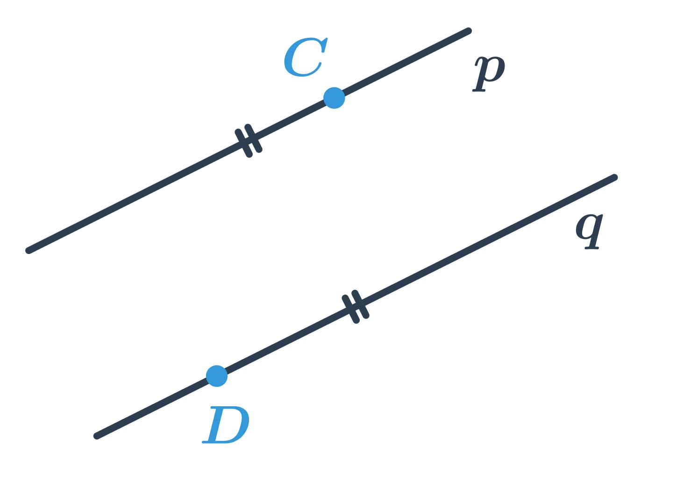

Purpose
# Source: AI Source: Provided by: [Data Path: Persons Table -> ID Column: 1, Name_En Column: Motasem Essam] -> From: [ChatGPT] on [7/25/2026]
Parallelism is used to:
- Describe the relationship between geometric lines.
- Identify lines that never meet.
- Analyze angles formed by parallel lines.
- Study properties of polygons.
- Construct geometric figures.
- Analyze coordinate geometry.
- Design structures and patterns.
- Support architecture, engineering, CAD, and surveying.

Fundamental Idea
# Source: AI Source: Provided by: [Data Path: Persons Table -> ID Column: 1, Name_En Column: Motasem Essam] -> From: [ChatGPT] on [7/25/2026]
Two lines are parallel if they lie in the same plane and never intersect.
For example:

──────────────────────── l₁

──────────────────────── l₂
The distance between the lines remains constant:
$$\boxed{d\left(l_{1},l_{2}\right)=\text{constant}}$$
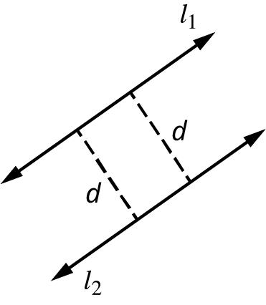
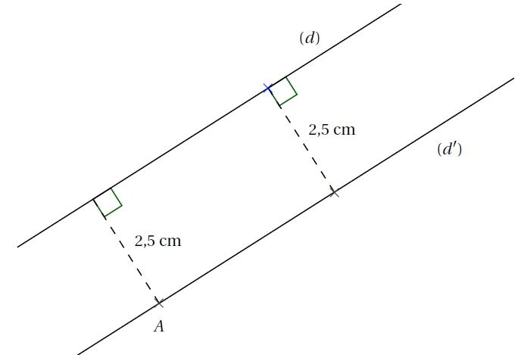
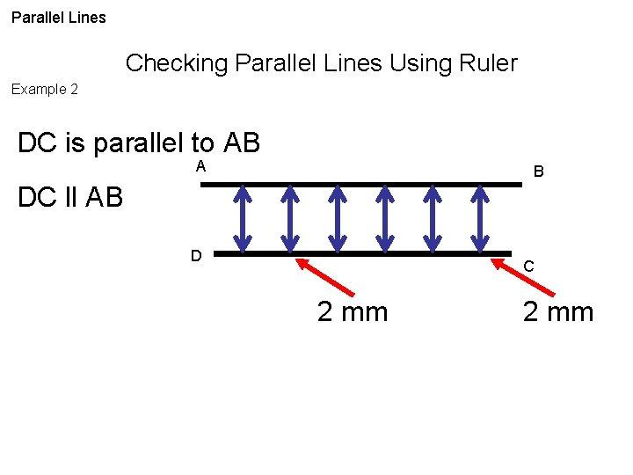
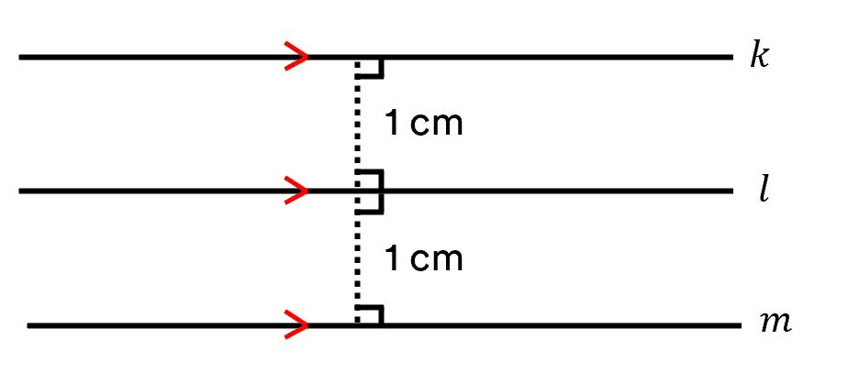

Notation
# Source: AI Source: Provided by: [Data Path: Persons Table -> ID Column: 1, Name_En Column: Motasem Essam] -> From: [ChatGPT] on [7/25/2026]
The symbol for parallelism is:
$$\boxed{∥}$$
Therefore:
$$\boxed{AB∥CD}$$
means that line $AB$ is parallel to line $CD$.
For two lines:
$$\boxed{l_{1}∥l_{2}}$$

Characteristics of Parallel Lines
# Source: AI Source: Provided by: [Data Path: Persons Table -> ID Column: 1, Name_En Column: Motasem Essam] -> From: [ChatGPT] on [7/25/2026]
Parallel lines have several important properties.
1. They lie in the same plane
In plane geometry, parallel lines are coplanar.
2. They never intersect
Even if extended infinitely:
$$\boxed{l_{1}∩l_{2}=∅}$$
3. Their distance remains constant
The perpendicular distance between them is constant.
4. They have the same direction
They point in the same direction.
5. They have the same slope
In coordinate geometry:
$$\boxed{m_{1}=m_{2}}$$
for two distinct non-vertical parallel lines.
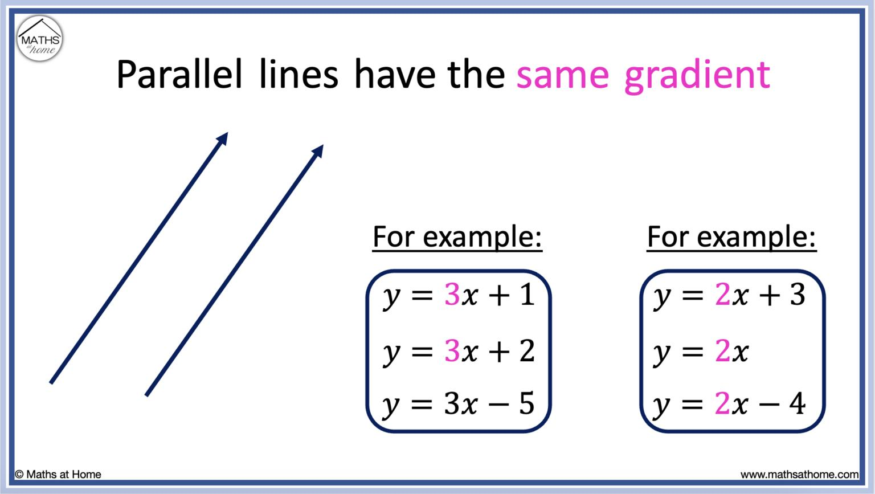
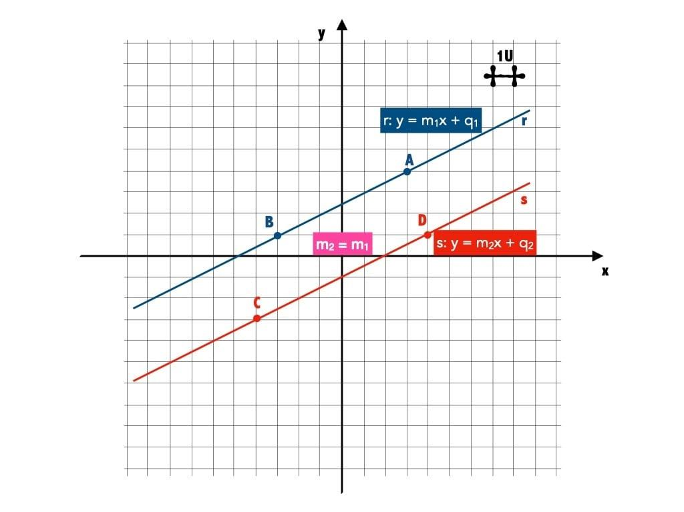
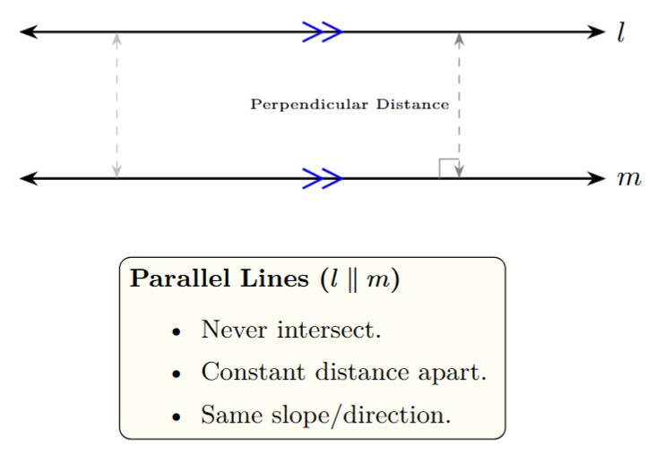
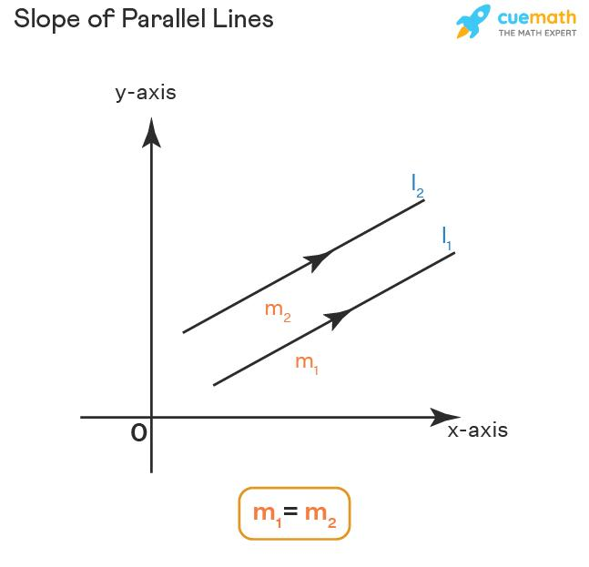
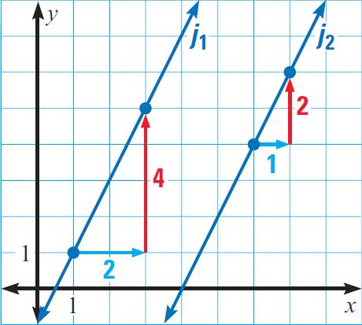

Parallel Line Segments
# Source: AI Source: Provided by: [Data Path: Persons Table -> ID Column: 1, Name_En Column: Motasem Essam] -> From: [ChatGPT] on [7/25/2026]
Two line segments can also be parallel.
For example:
$$\boxed{\overline{AB}∥\overline{CD}}$$
The segments do not need to have the same length.
They only need to have the same direction when considered as portions of lines.
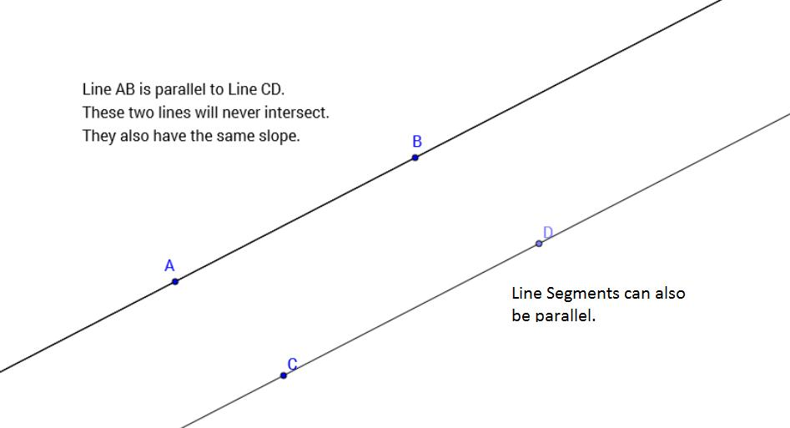
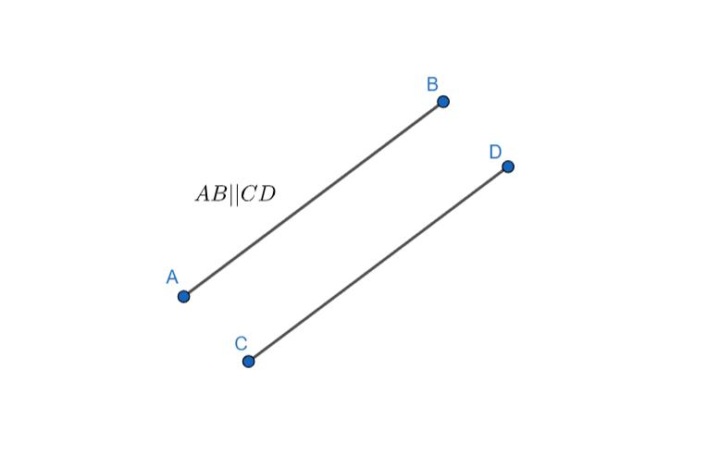

Parallel Rays
# Source: AI Source: Provided by: [Data Path: Persons Table -> ID Column: 1, Name_En Column: Motasem Essam] -> From: [ChatGPT] on [7/25/2026]
Two rays can also be parallel if they extend in the same direction without intersecting.
For example:
$$\boxed{\overset{→}{AB}∥\overset{→}{CD}}$$
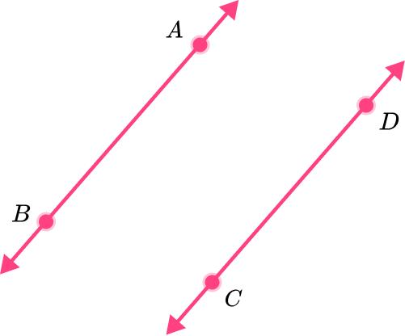
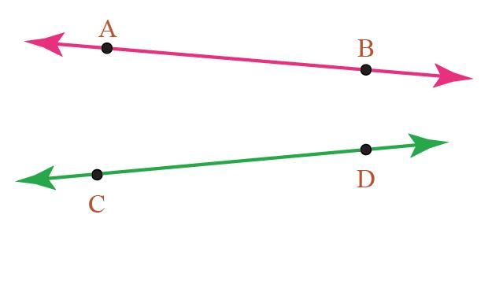
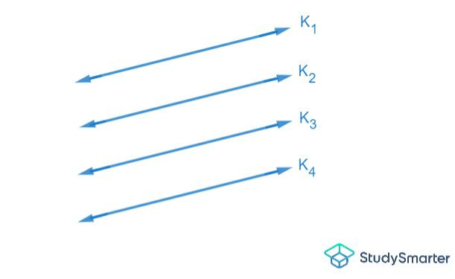

Parallelism in Polygons
# Source: AI Source: Provided by: [Data Path: Persons Table -> ID Column: 1, Name_En Column: Motasem Essam] -> From: [ChatGPT] on [7/25/2026]
Parallelism is an important property of many polygons.

Parallelogram
# Source: AI Source: Provided by: [Data Path: Persons Table -> ID Column: 1, Name_En Column: Motasem Essam] -> From: [ChatGPT] on [7/25/2026]
A parallelogram has two pairs of parallel opposite sides.
$$\boxed{AB∥CD}$$
and:
$$\boxed{AD∥BC}$$
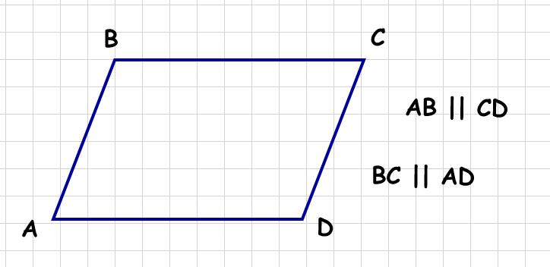
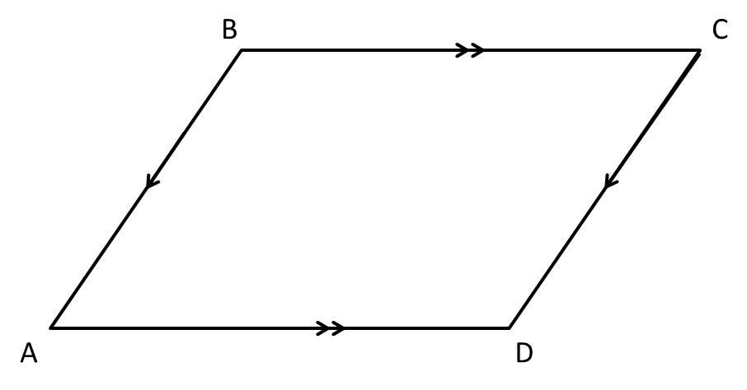
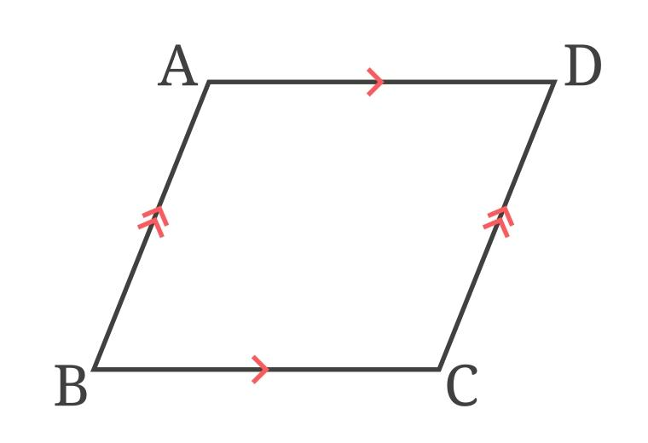
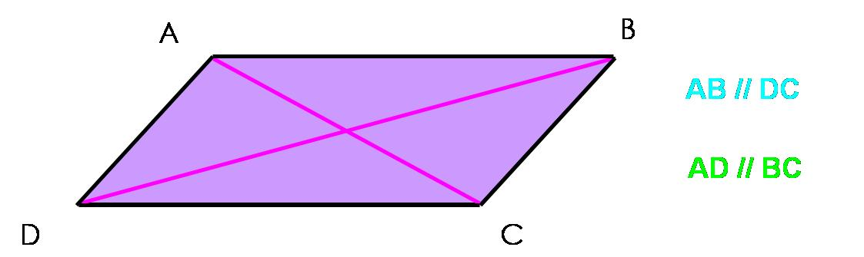
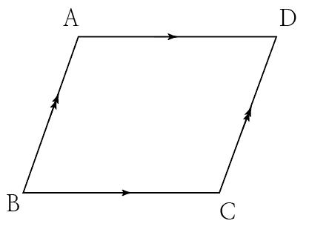

Rectangle
# Source: AI Source: Provided by: [Data Path: Persons Table -> ID Column: 1, Name_En Column: Motasem Essam] -> From: [ChatGPT] on [7/25/2026]
A rectangle has two pairs of parallel opposite sides.
$$\boxed{AB∥CD} \\ \boxed{AD∥BC}$$
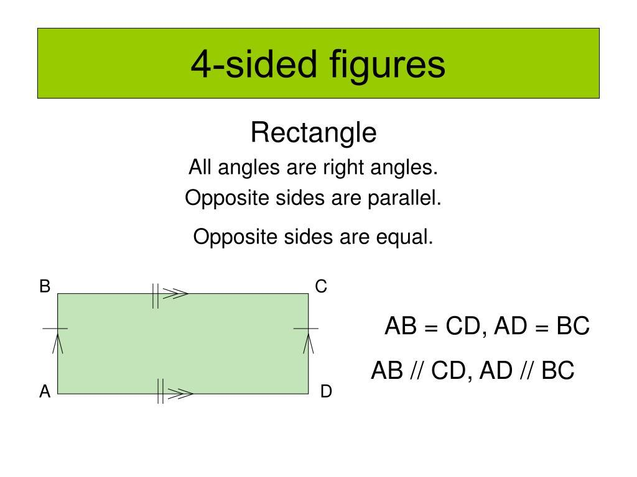
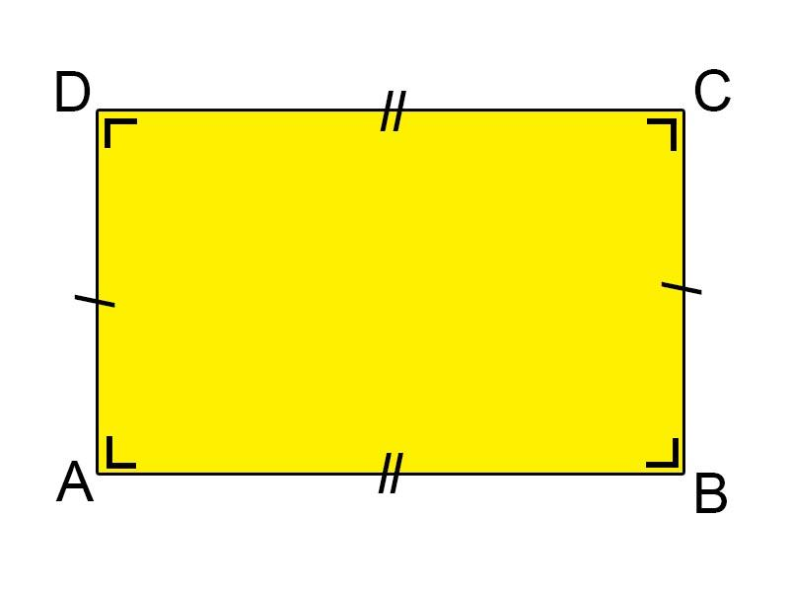
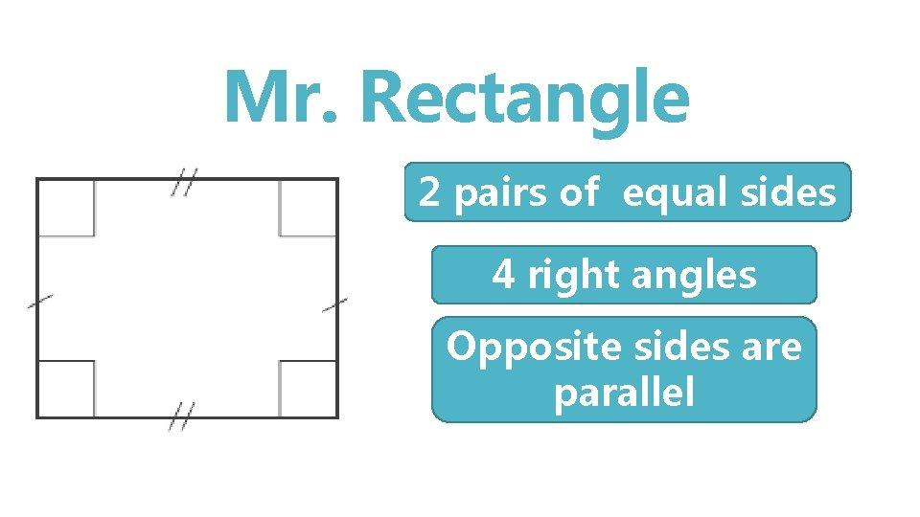

Square
# Source: AI Source: Provided by: [Data Path: Persons Table -> ID Column: 1, Name_En Column: Motasem Essam] -> From: [ChatGPT] on [7/25/2026]
A square also has two pairs of parallel opposite sides.
$$\boxed{AB∥CD} \\ \boxed{AD∥BC}$$
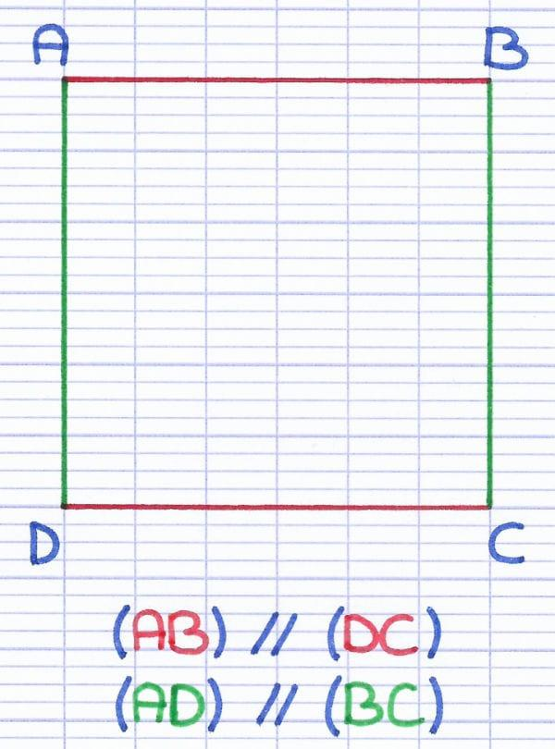
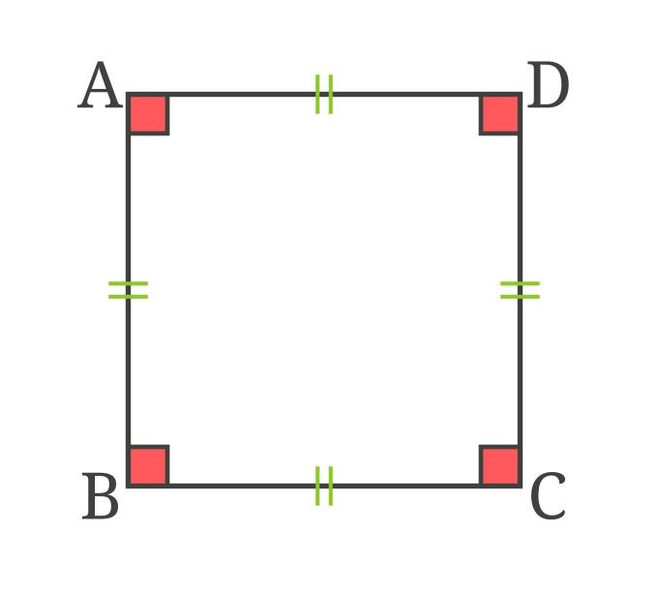
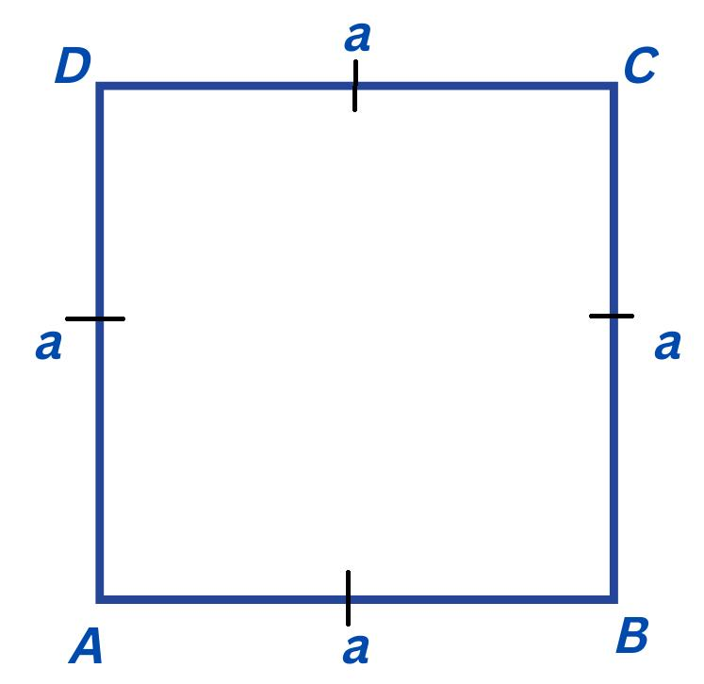
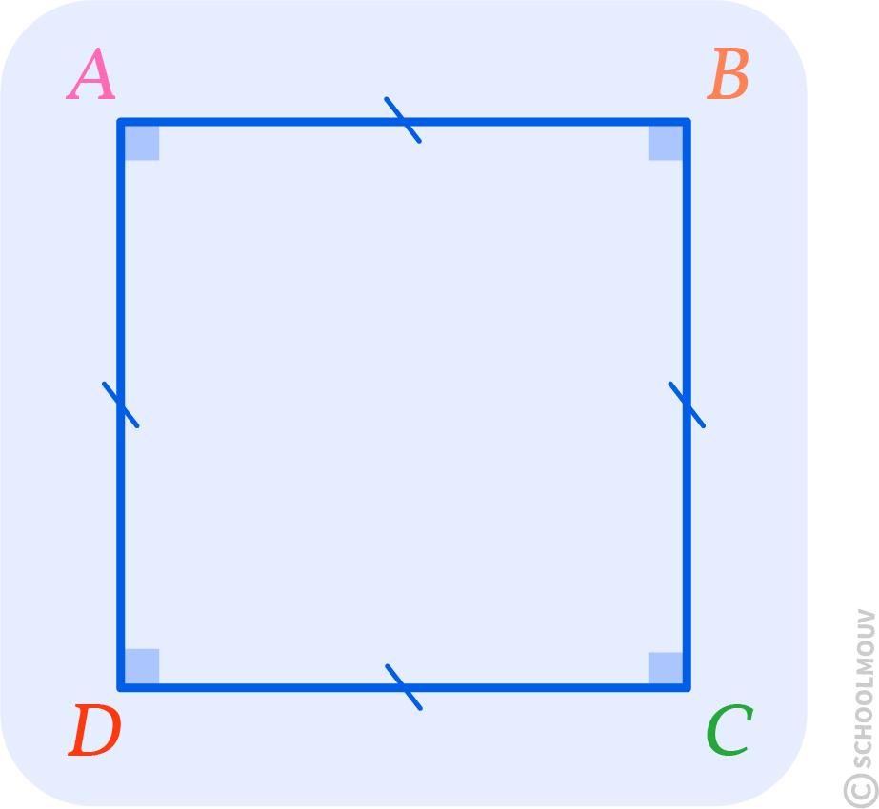

Trapezoid
# Source: AI Source: Provided by: [Data Path: Persons Table -> ID Column: 1, Name_En Column: Motasem Essam] -> From: [ChatGPT] on [7/25/2026]
A trapezoid has at least one pair of parallel sides under the common definition.
These sides are called the bases.
$$\boxed{AB∥CD}$$
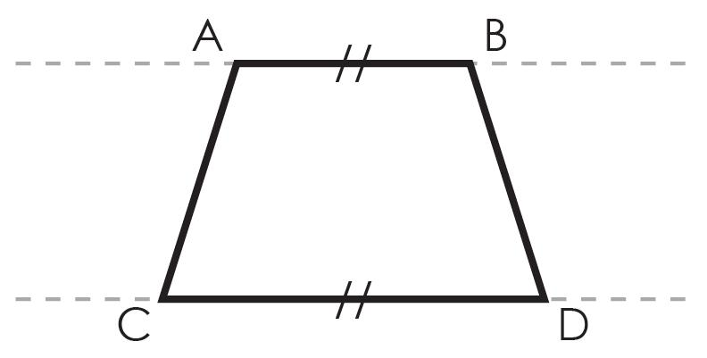
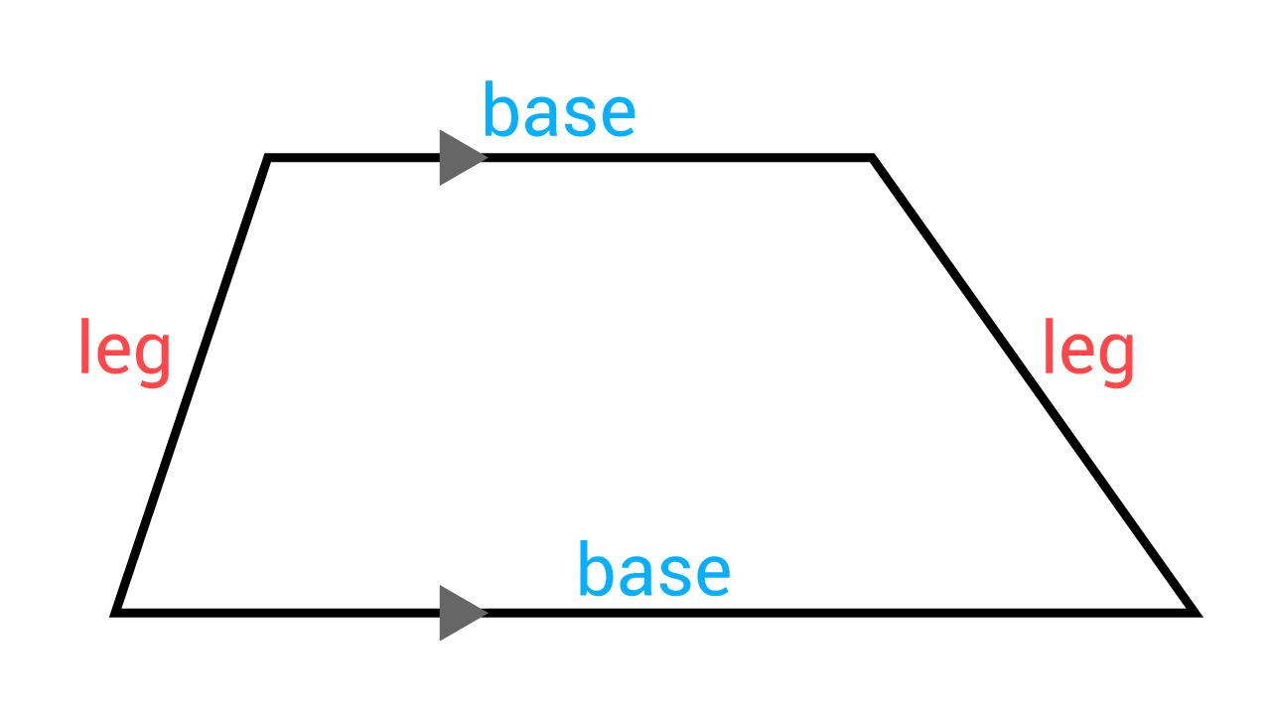
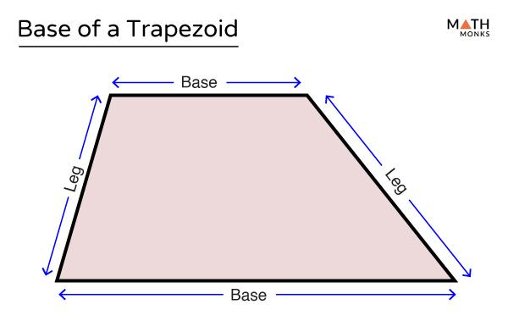
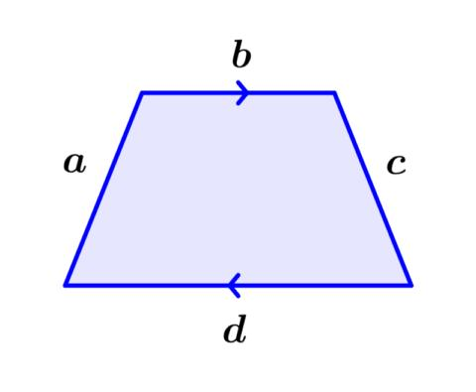
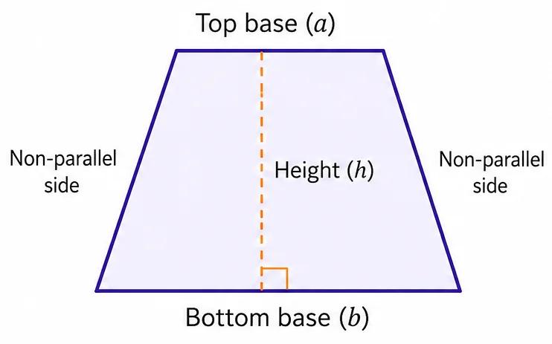

Parallel Lines and a Transversal
# Source: AI Source: Provided by: [Data Path: Persons Table -> ID Column: 1, Name_En Column: Motasem Essam] -> From: [ChatGPT] on [7/25/2026]
A transversal is a line that intersects two or more lines at different points.
When a transversal crosses two parallel lines, several important angle relationships are created.
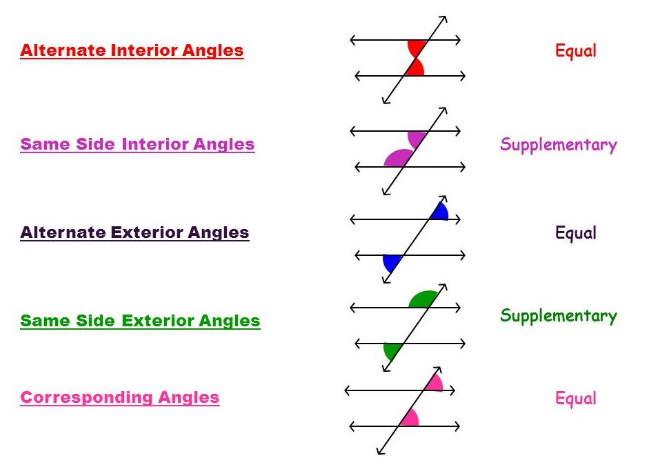
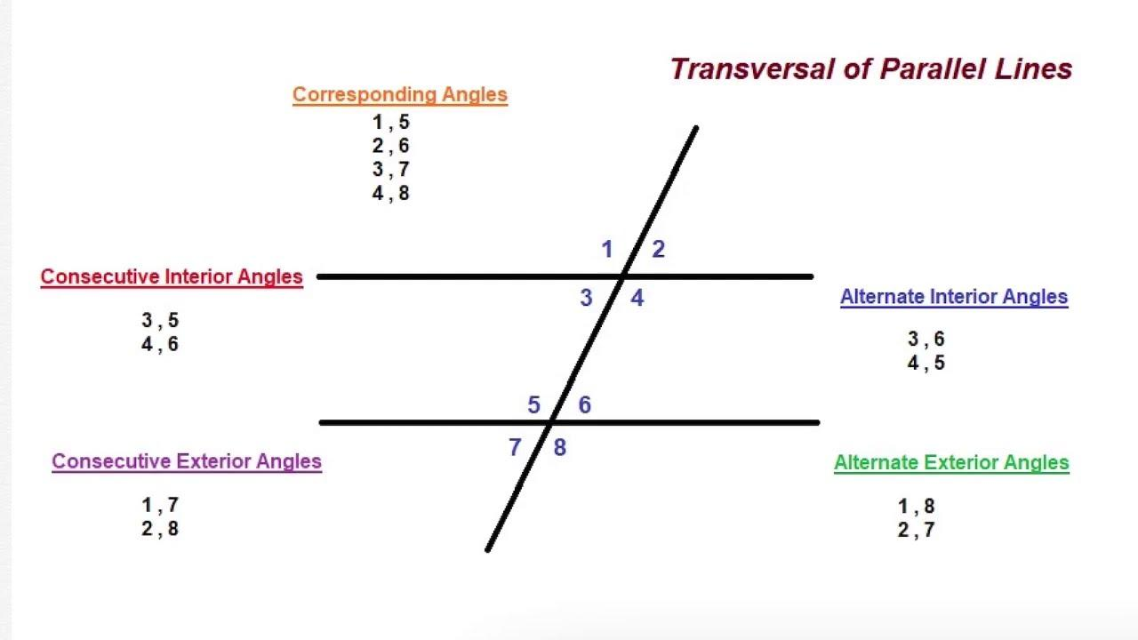
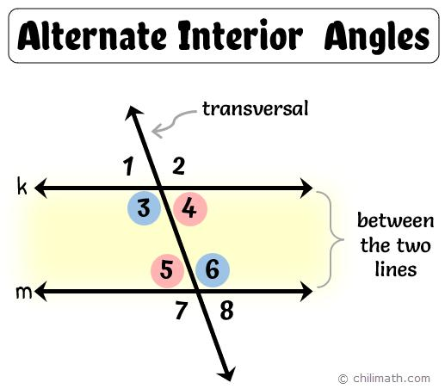
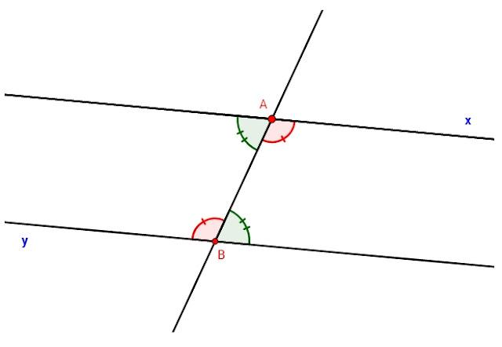
The important angle relationships include:
- Corresponding angles.
- Alternate interior angles.
- Alternate exterior angles.
- Same-side interior angles.

Corresponding Angles
# Source: AI Source: Provided by: [Data Path: Persons Table -> ID Column: 1, Name_En Column: Motasem Essam] -> From: [ChatGPT] on [7/25/2026]
When a transversal intersects two parallel lines, corresponding angles are equal.
If:
$$l_{1}∥l_{2}$$
then:
$$\boxed{∠1=∠2}$$
for corresponding angles.
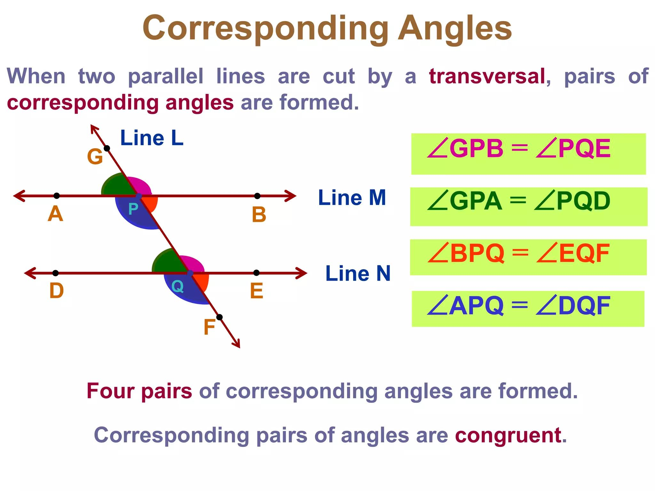
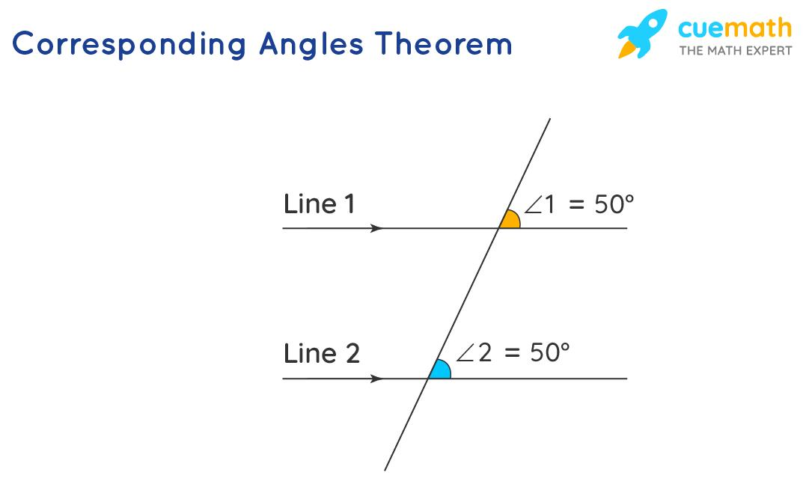
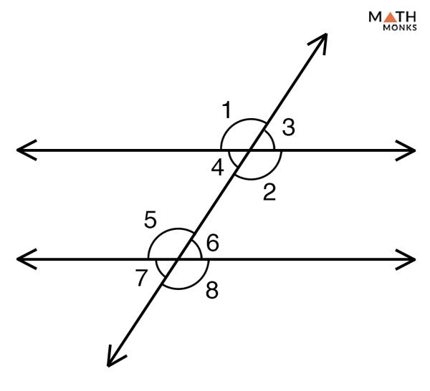
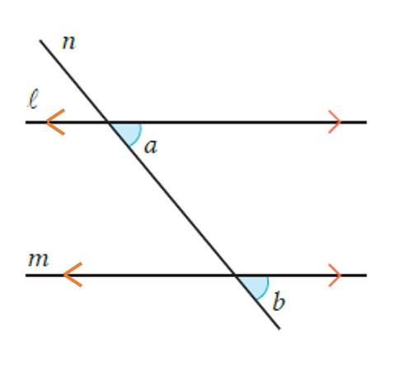
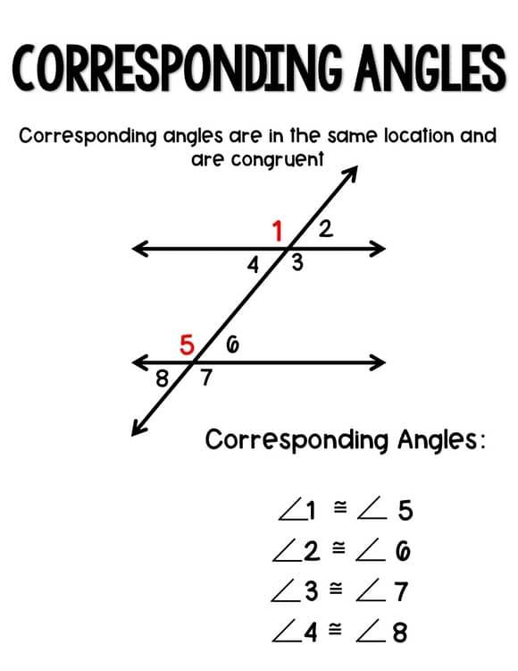

Alternate Interior Angles
# Source: AI Source: Provided by: [Data Path: Persons Table -> ID Column: 1, Name_En Column: Motasem Essam] -> From: [ChatGPT] on [7/25/2026]
Alternate interior angles lie between the two parallel lines and on opposite sides of the transversal.
When the lines are parallel:
$$\boxed{∠1=∠2}$$
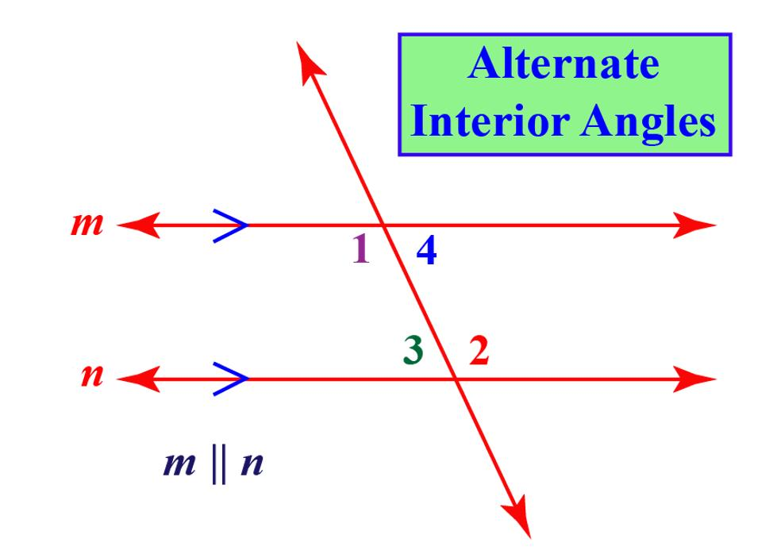
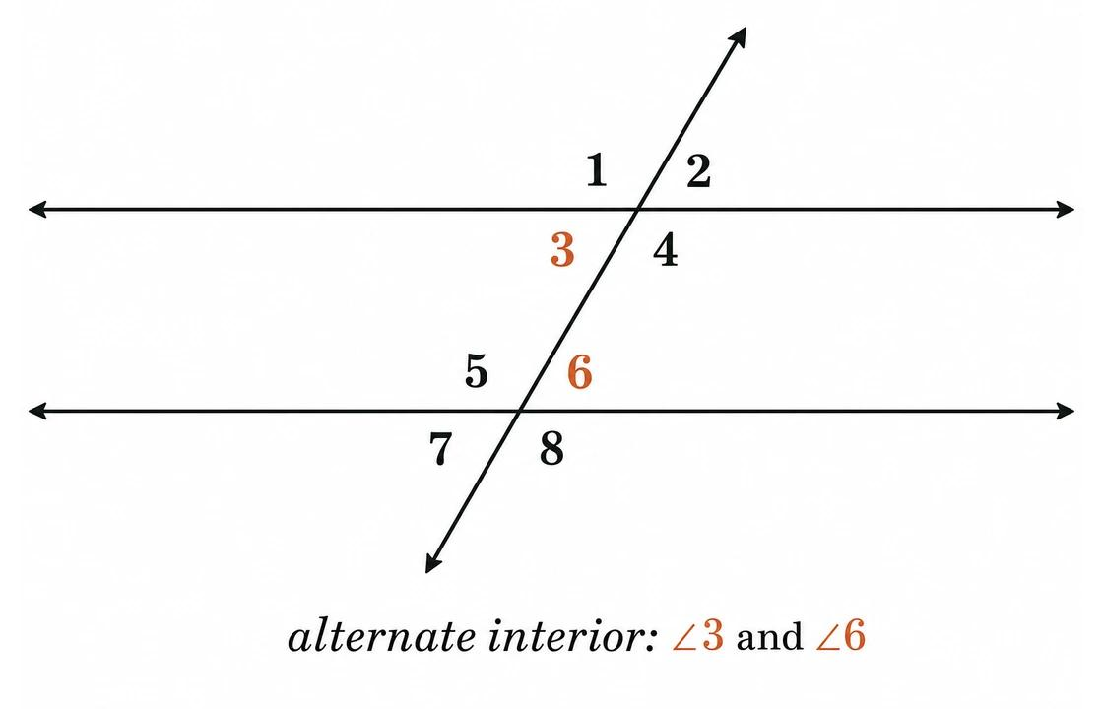
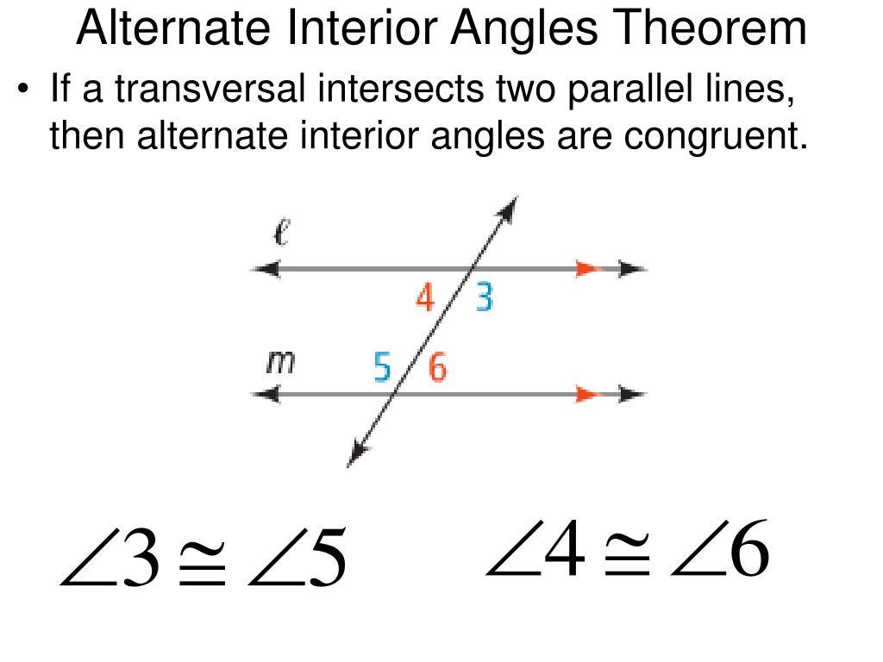
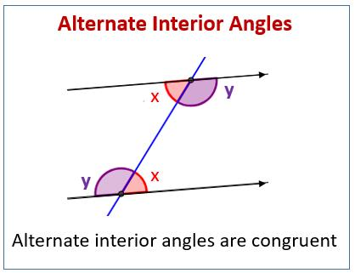
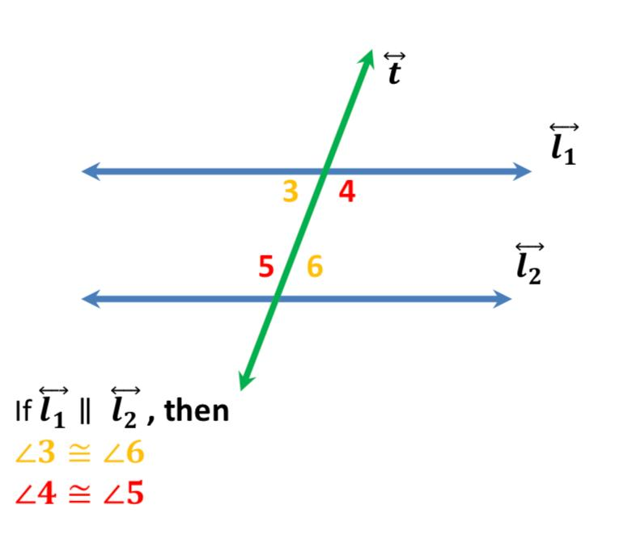

Alternate Exterior Angles
# Source: AI Source: Provided by: [Data Path: Persons Table -> ID Column: 1, Name_En Column: Motasem Essam] -> From: [ChatGPT] on [7/25/2026]
Alternate exterior angles lie outside the two parallel lines and on opposite sides of the transversal.
When the lines are parallel:
$$\boxed{∠1=∠2}$$
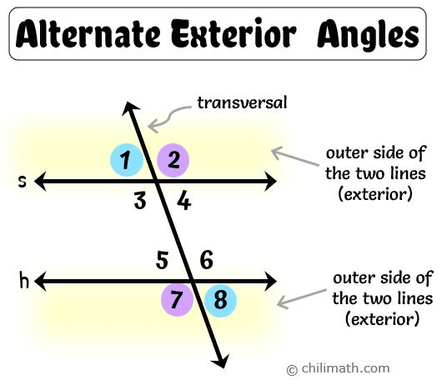
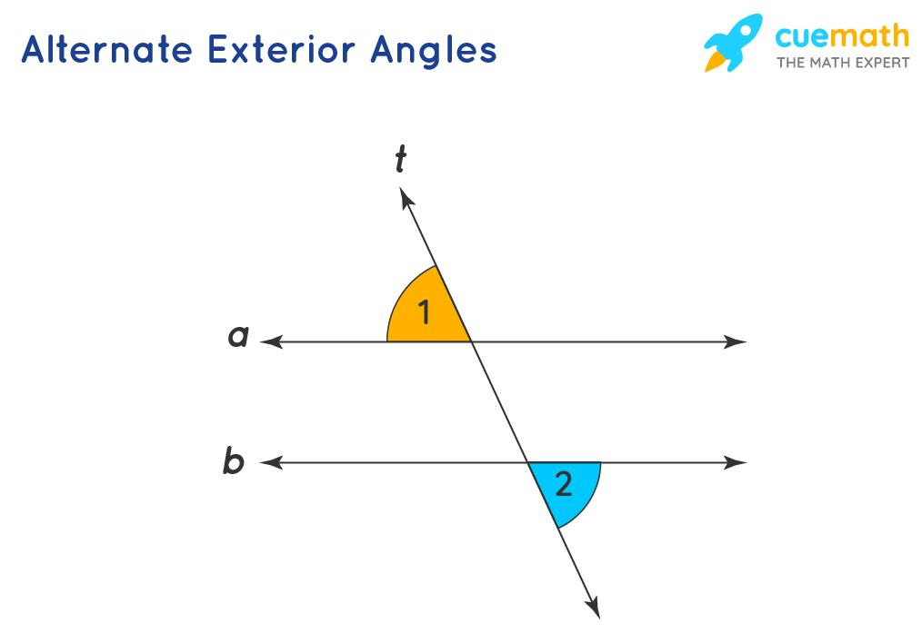
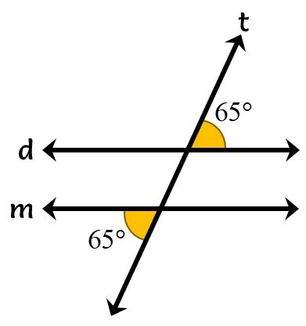
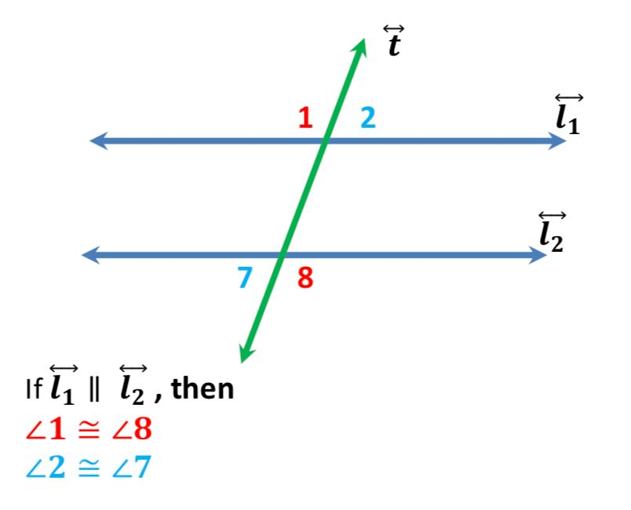
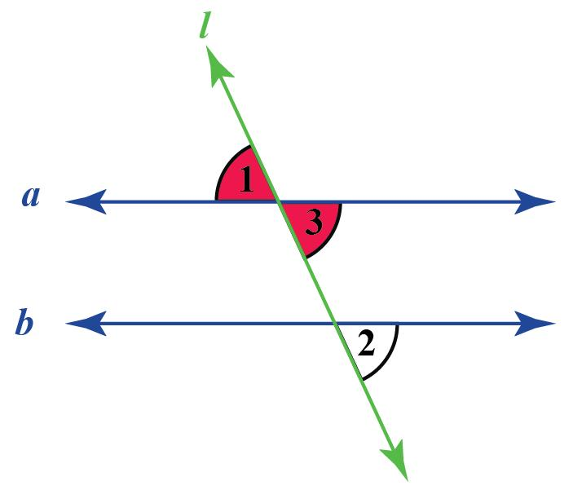

Same-Side Interior Angles
# Source: AI Source: Provided by: [Data Path: Persons Table -> ID Column: 1, Name_En Column: Motasem Essam] -> From: [ChatGPT] on [7/25/2026]
Same-side interior angles lie between the parallel lines and on the same side of the transversal.
They are supplementary:
$$\boxed{∠1+∠2={180}^{∘}}$$
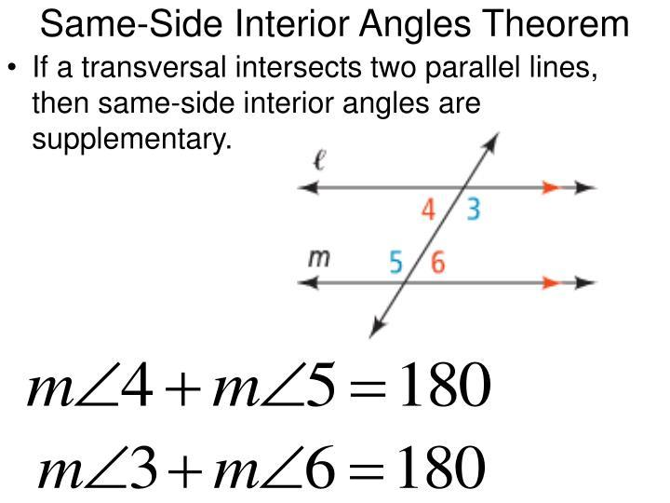
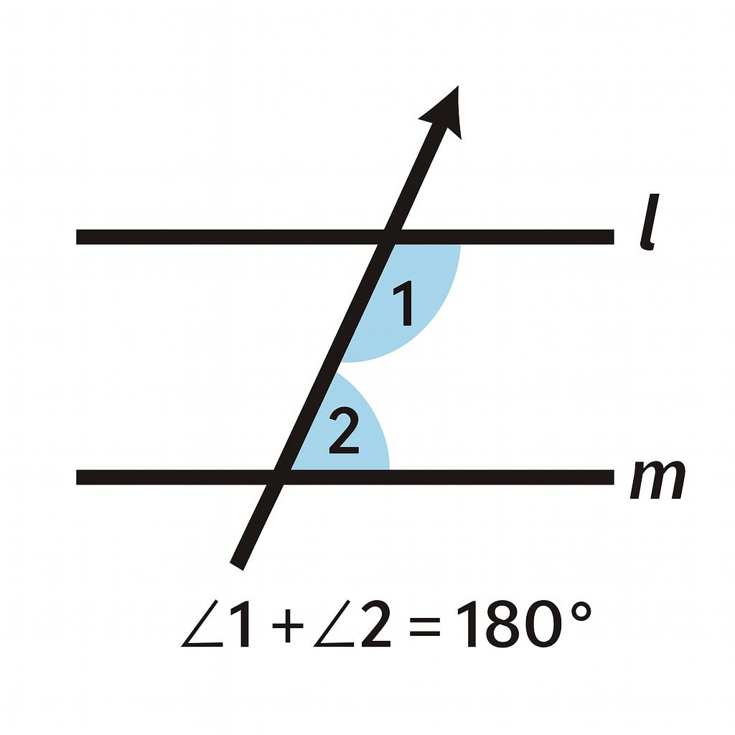
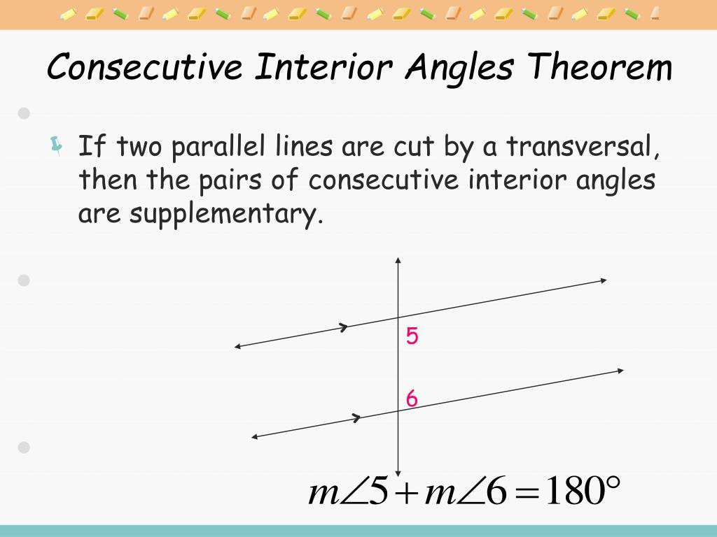
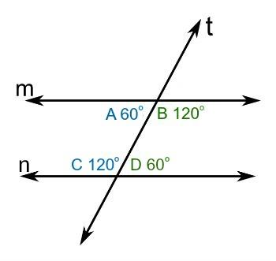
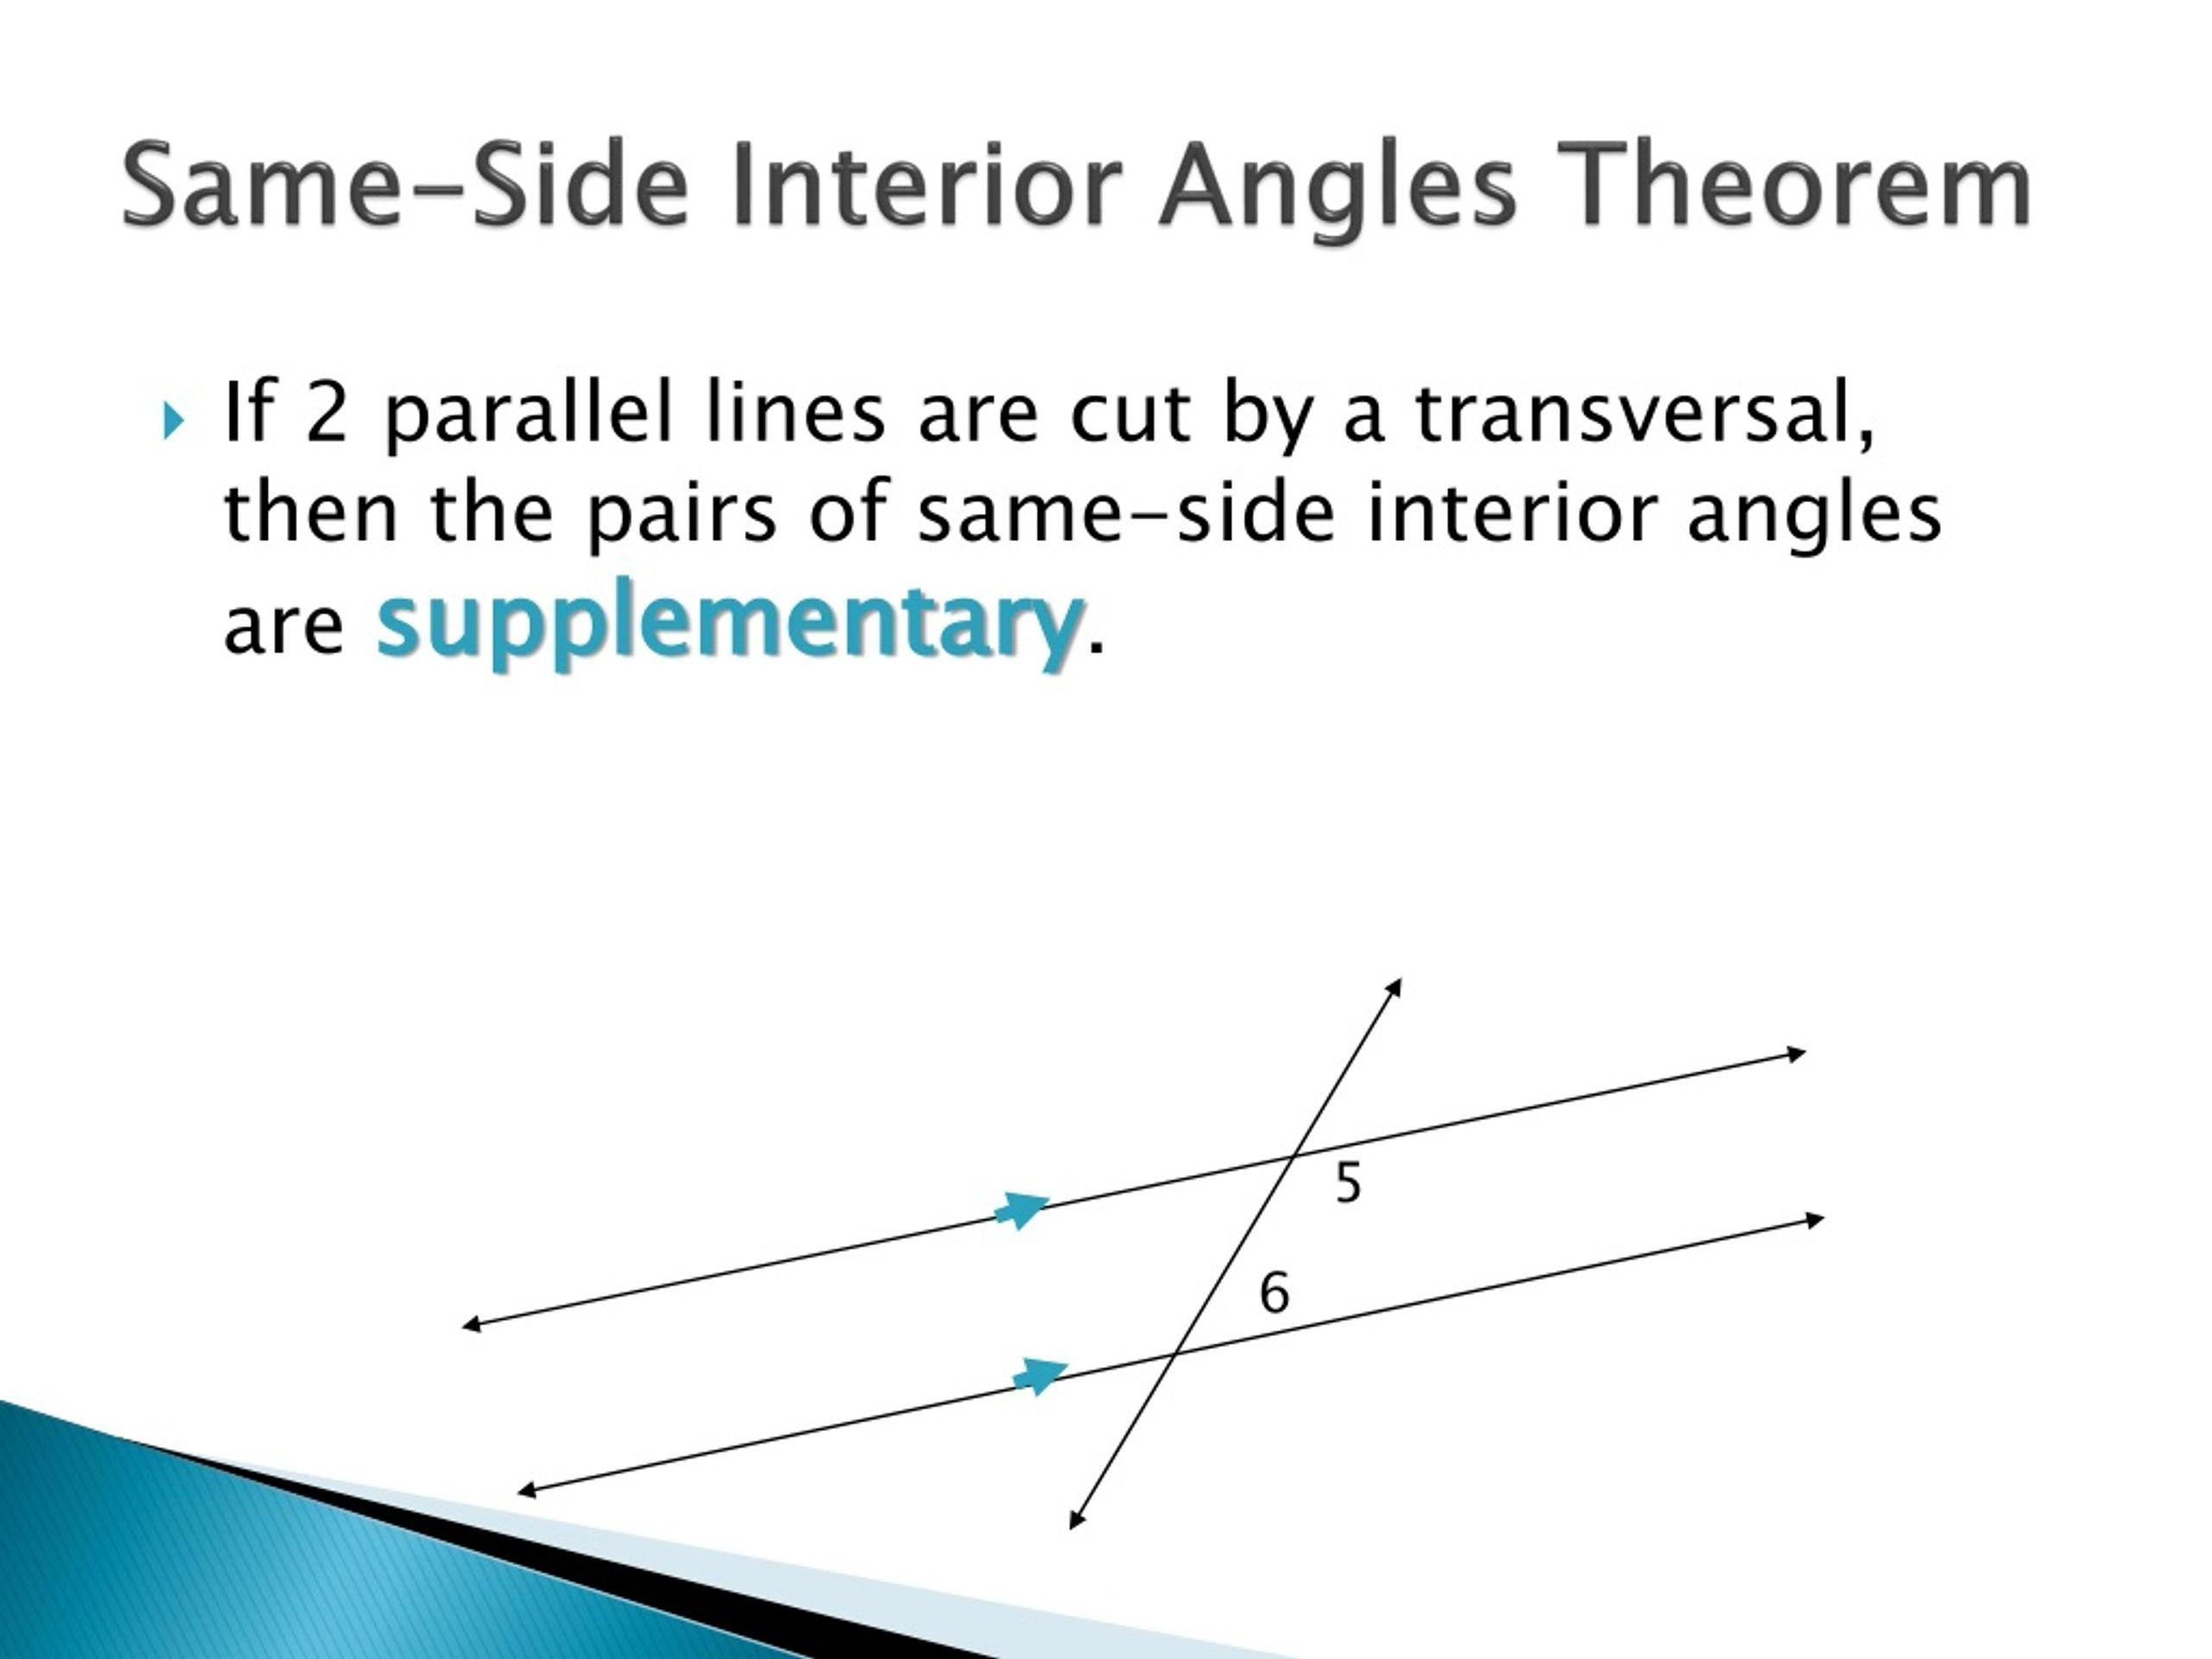

Parallelism and Perpendicularity
# Source: AI Source: Provided by: [Data Path: Persons Table -> ID Column: 1, Name_En Column: Motasem Essam] -> From: [ChatGPT] on [7/25/2026]
Parallelism and perpendicularity are different geometric relationships.
Parallel Lines
$$\boxed{l_{1}∥l_{2}}$$
They never intersect.
Perpendicular Lines
$$\boxed{l_{1}⊥l_{2}}$$
They intersect at:
$$\boxed{{90}^{∘}}$$
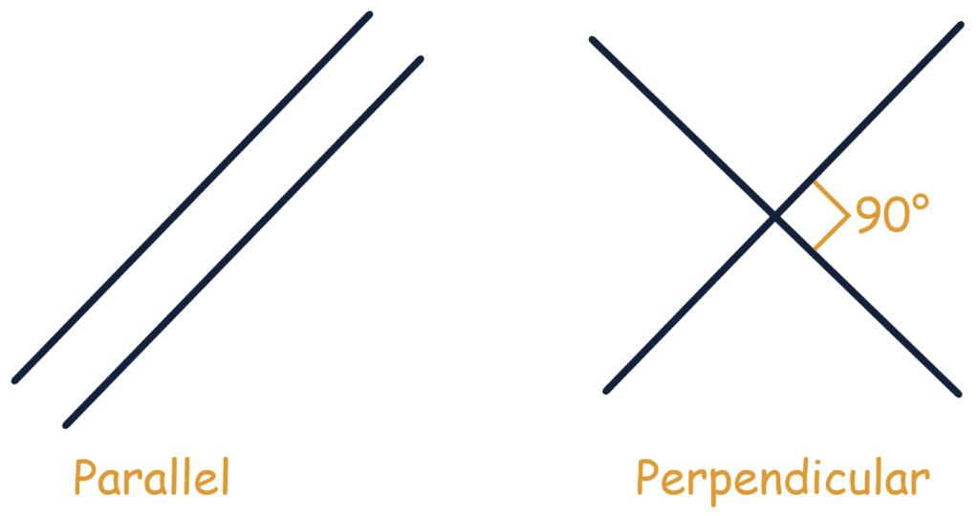
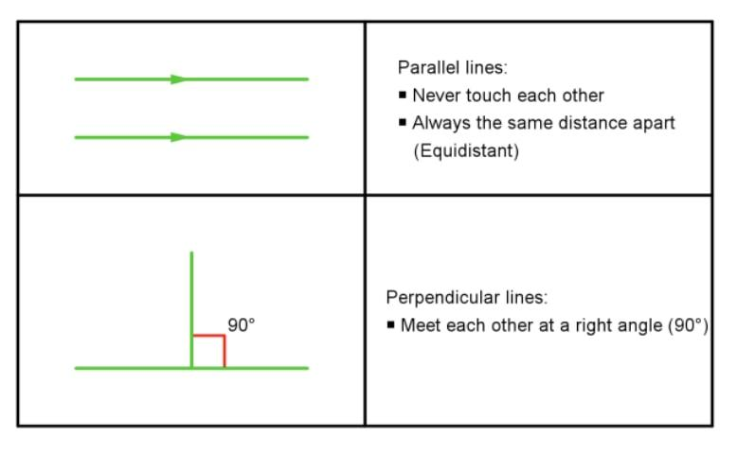
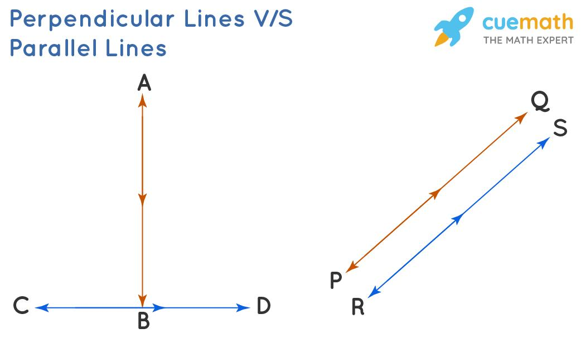

Parallelism in Coordinate Geometry
# Source: AI Source: Provided by: [Data Path: Persons Table -> ID Column: 1, Name_En Column: Motasem Essam] -> From: [ChatGPT] on [7/25/2026]
In coordinate geometry, parallel lines can be identified using their slopes.
For two non-vertical lines:
$$y=m_{1}x+b_{1}$$
and:
$$y=m_{2}x+b_{2}$$
the lines are parallel when:
$$\boxed{m_{1}=m_{2}}$$
provided that the lines are distinct.
Example
Consider:
$$y=2x+3$$
and:
$$y=2x-5$$
Their slopes are:
$$m_{1}=2$$
and:
$$m_{2}=2$$
Therefore:
$$\boxed{m_{1}=m_{2}}$$
so the lines are parallel.
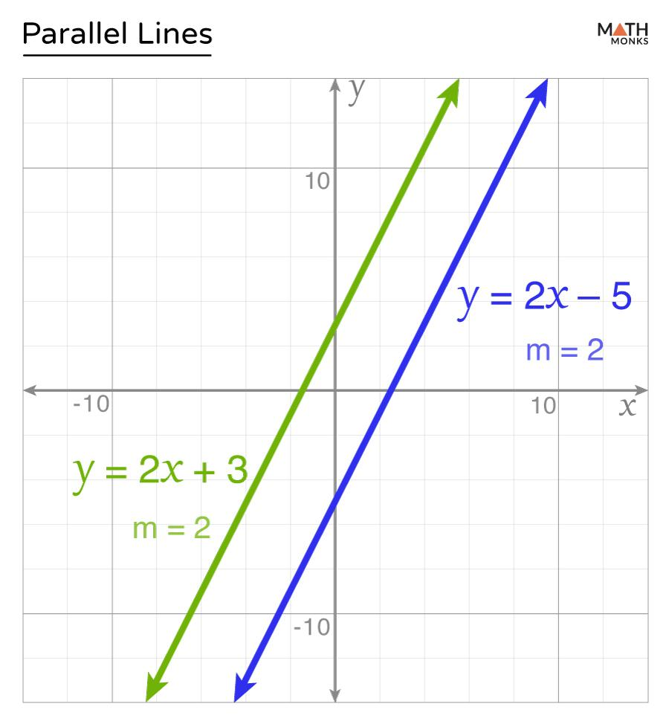
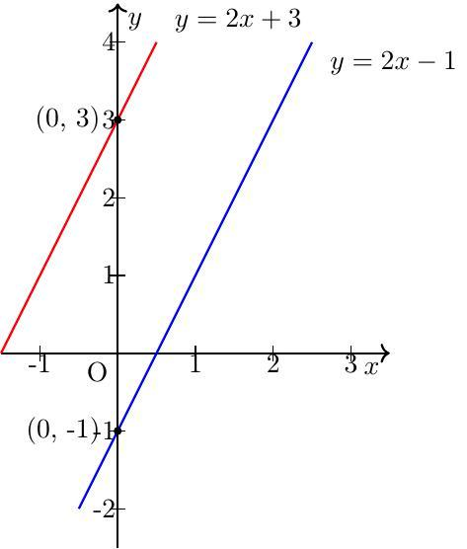
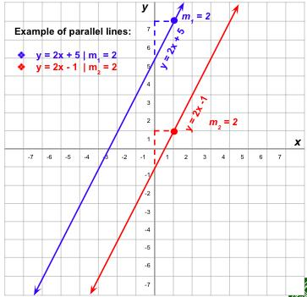

Vertical Parallel Lines
# Source: AI Source: Provided by: [Data Path: Persons Table -> ID Column: 1, Name_En Column: Motasem Essam] -> From: [ChatGPT] on [7/25/2026]
Vertical lines do not have a finite numerical slope, but two distinct vertical lines are parallel.
For example:
$$\boxed{x=2}$$
and:
$$\boxed{x=7}$$
are parallel.
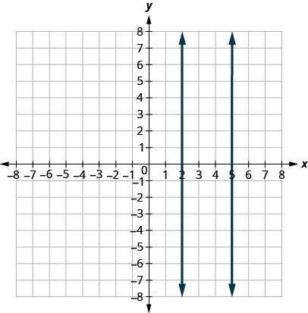
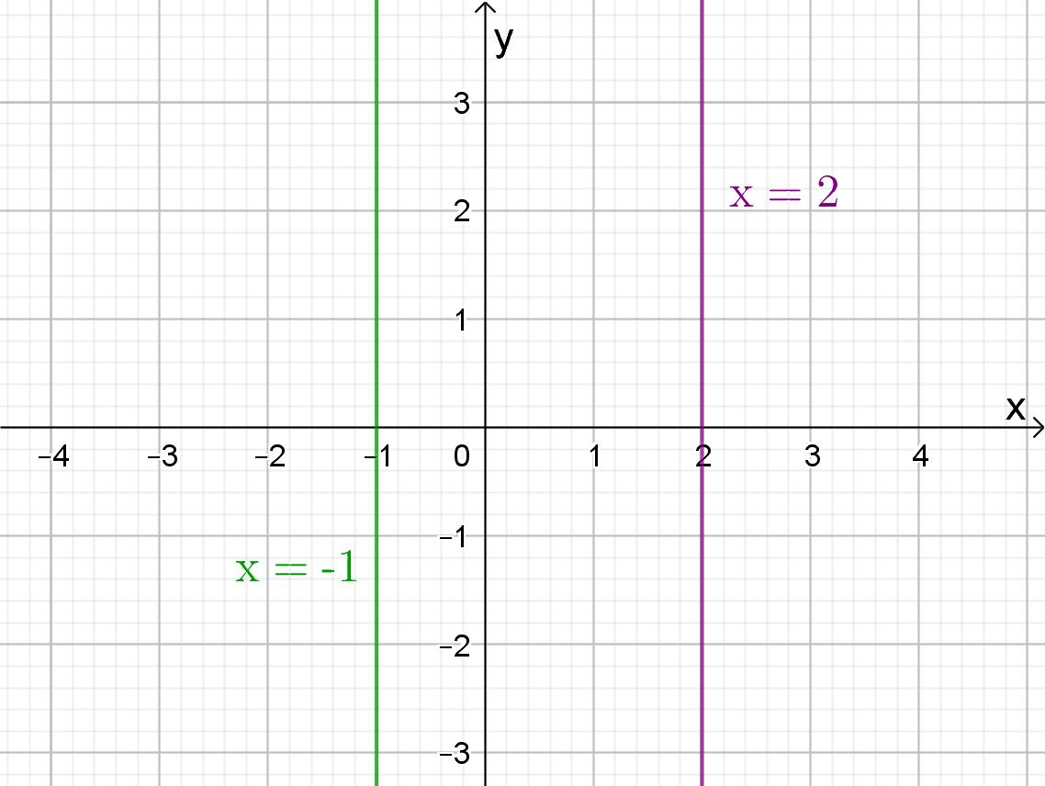
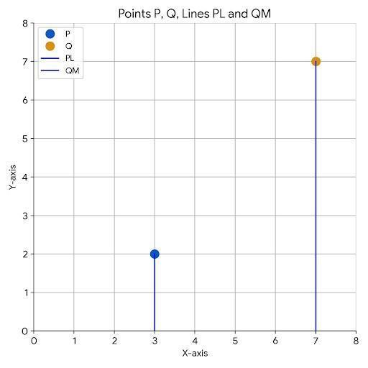

Parallelism and Distance
# Source: AI Source: Provided by: [Data Path: Persons Table -> ID Column: 1, Name_En Column: Motasem Essam] -> From: [ChatGPT] on [7/25/2026]
The perpendicular distance between two parallel lines is constant.
If the lines are:
$$l_{1}$$
and:
$$l_{2}$$
then:
$$\boxed{d\left(l_{1},l_{2}\right)=\text{constant}}$$
The shortest distance between them is measured along a perpendicular segment.
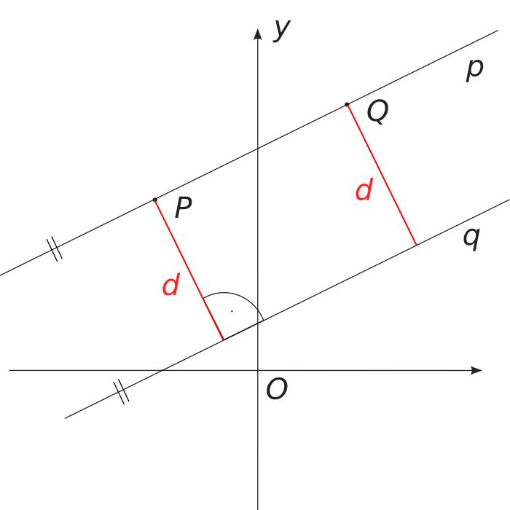
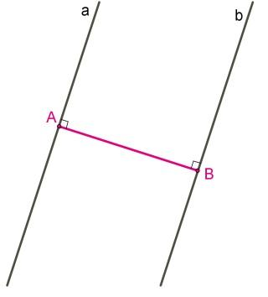
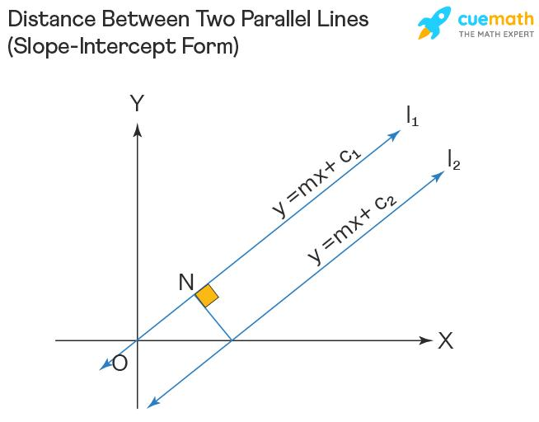
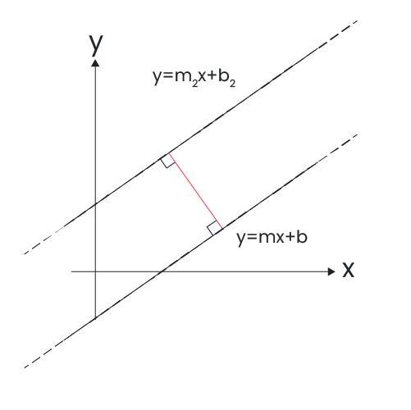

Parallelism and Angles
# Source: AI Source: Provided by: [Data Path: Persons Table -> ID Column: 1, Name_En Column: Motasem Essam] -> From: [ChatGPT] on [7/25/2026]
Parallelism allows us to determine unknown angles.
For example, if two parallel lines are crossed by a transversal and one angle is:
$${70}^{∘}$$
then its corresponding angle is also:
$$\boxed{{70}^{∘}}$$
while a same-side interior angle is:
$${180}^{∘}-{70}^{∘}={110}^{∘}$$
Therefore:
$$\boxed{{70}^{∘}+{110}^{∘}={180}^{∘}}$$

Parallelism and Transitivity
# Source: AI Source: Provided by: [Data Path: Persons Table -> ID Column: 1, Name_En Column: Motasem Essam] -> From: [ChatGPT] on [7/25/2026]
Parallelism has a transitive property.
If:
$$l_{1}∥l_{2}$$
and:
$$l_{2}∥l_{3}$$
then:
$$\boxed{l_{1}∥l_{3}}$$
provided the lines are considered within the same plane.
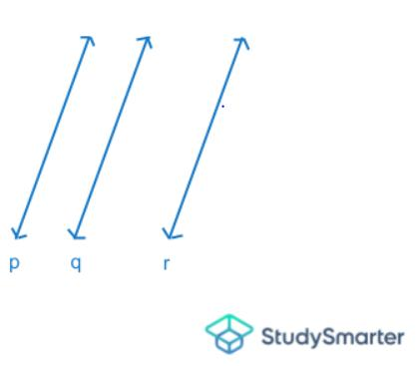
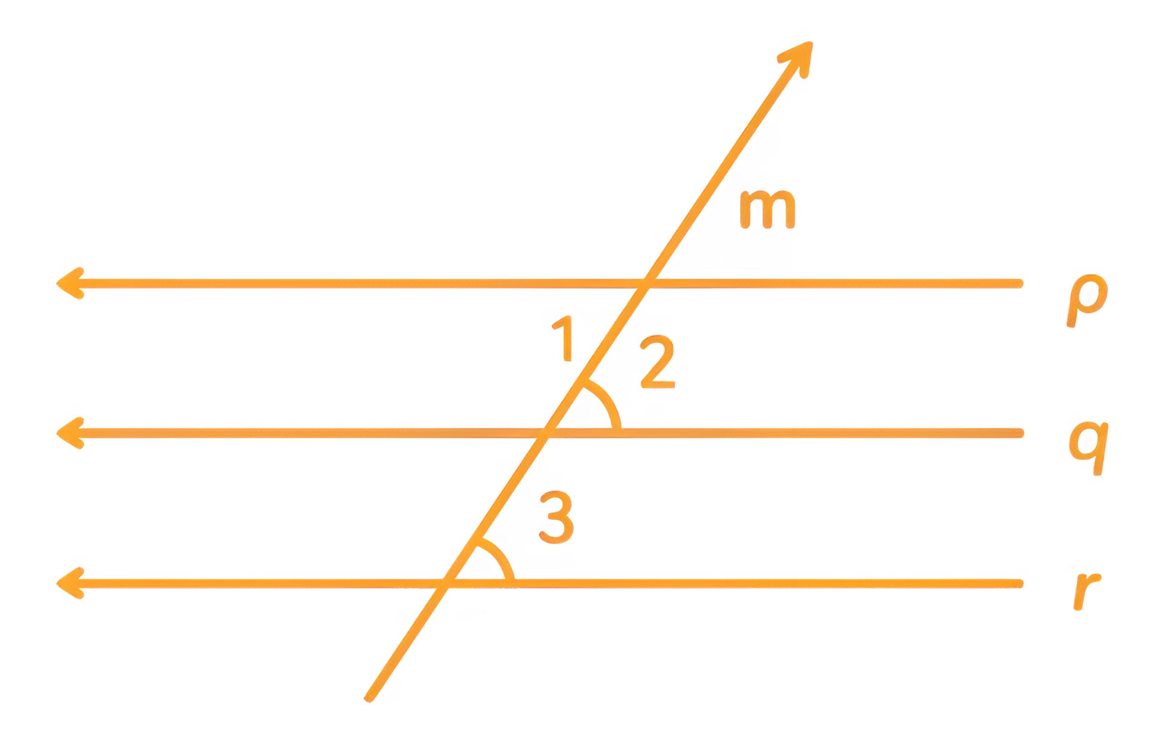
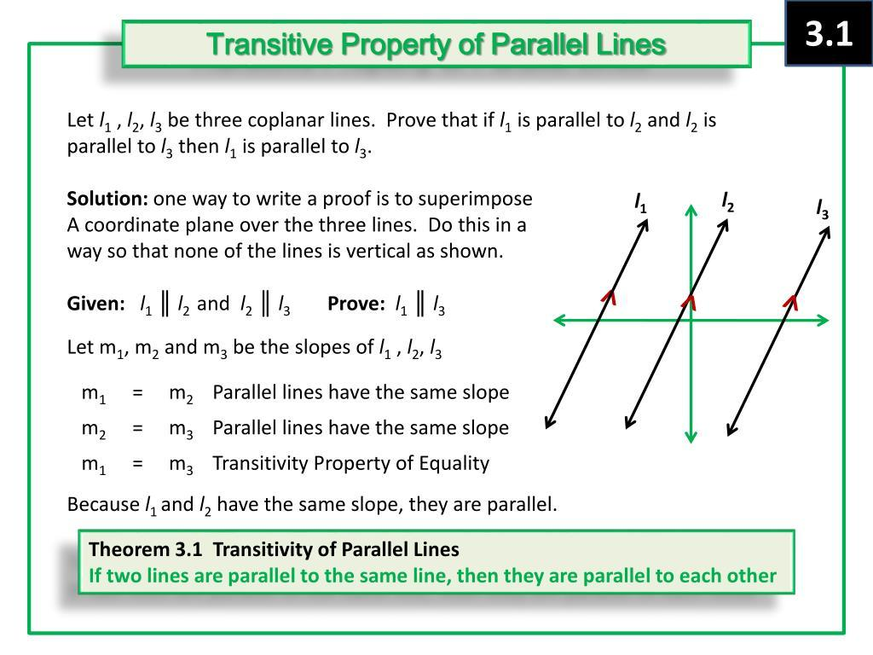

Parallelism and Euclidean Geometry
# Source: AI Source: Provided by: [Data Path: Persons Table -> ID Column: 1, Name_En Column: Motasem Essam] -> From: [ChatGPT] on [7/25/2026]
In Euclidean plane geometry, an important principle is the parallel postulate.
Through a point not on a given line, there is exactly one line parallel to the given line.
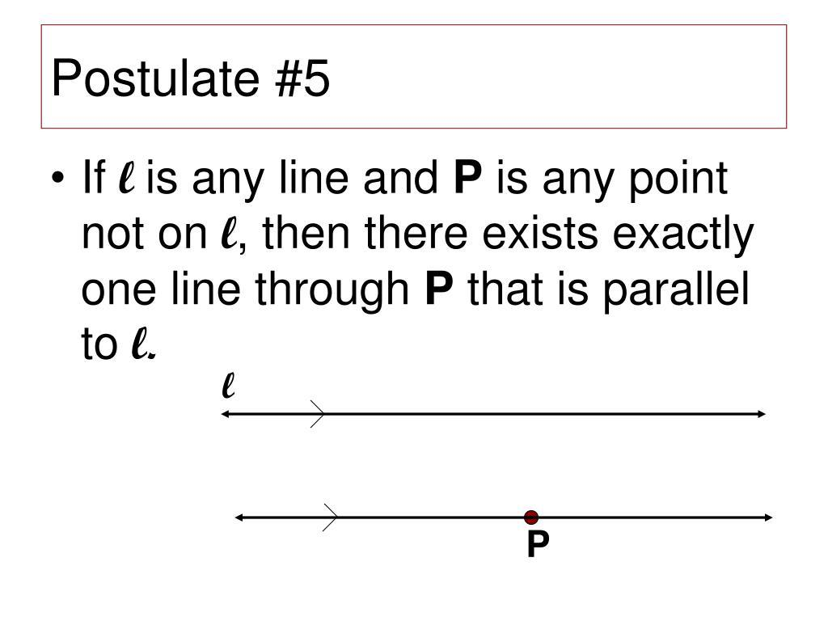
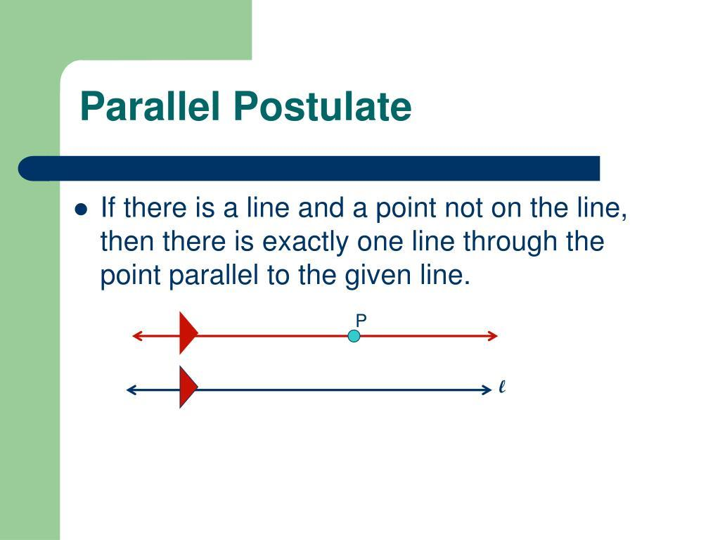
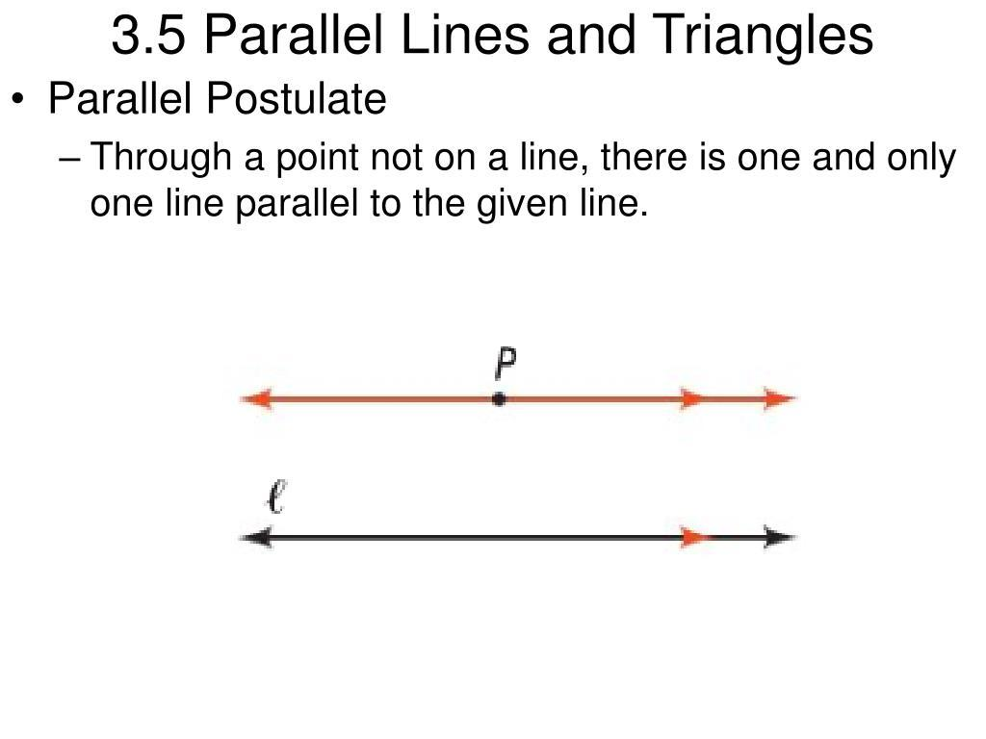
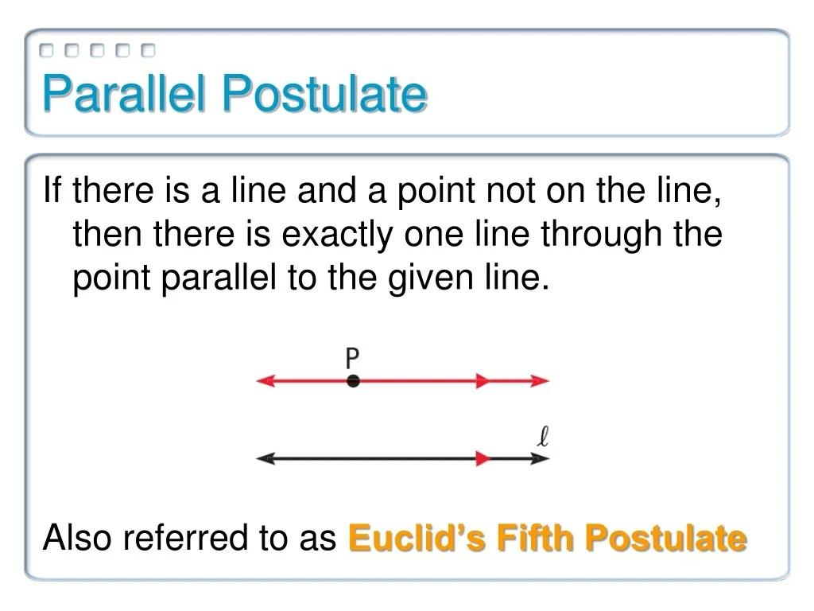
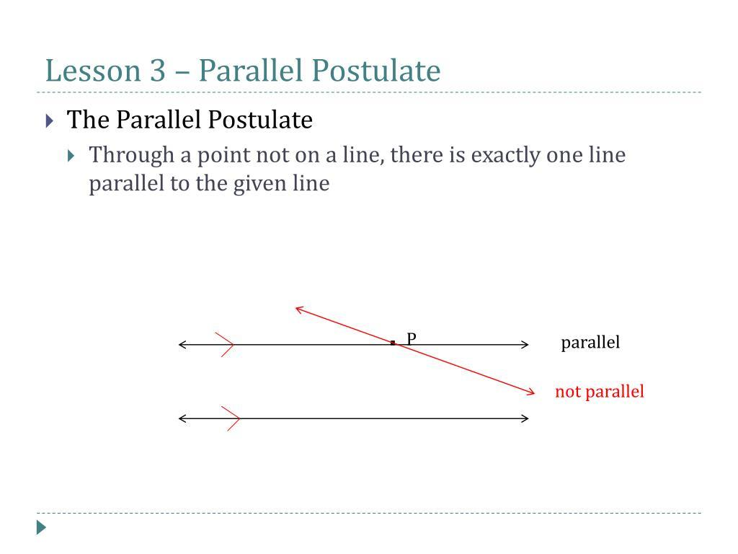
This principle is fundamental to classical Euclidean geometry.

Parallelism in Triangles
# Source: AI Source: Provided by: [Data Path: Persons Table -> ID Column: 1, Name_En Column: Motasem Essam] -> From: [ChatGPT] on [7/25/2026]
Parallel lines can create important relationships within triangles.
For example, if a line is drawn parallel to one side of a triangle, it can create a smaller triangle that is similar to the original triangle.
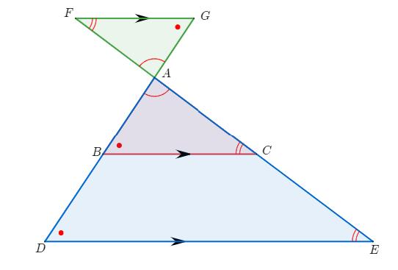
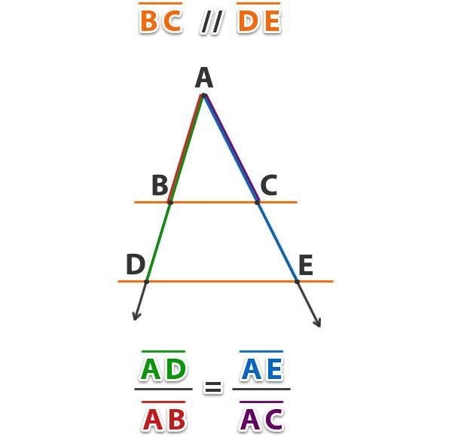
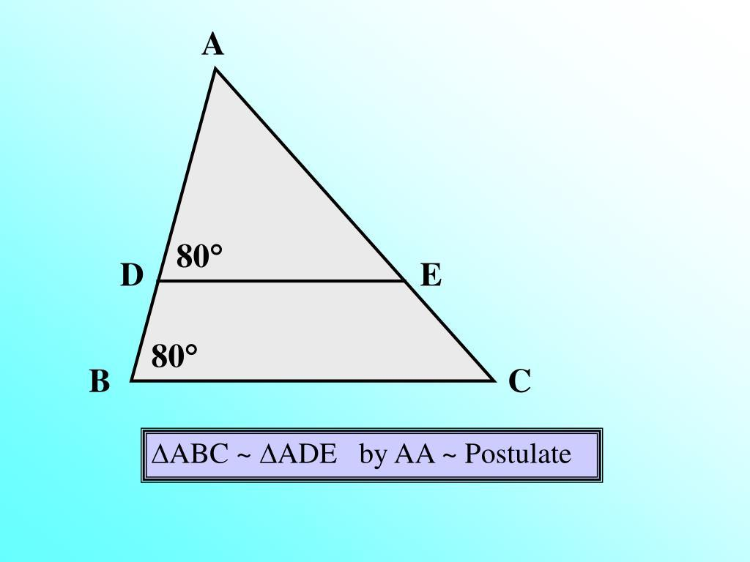
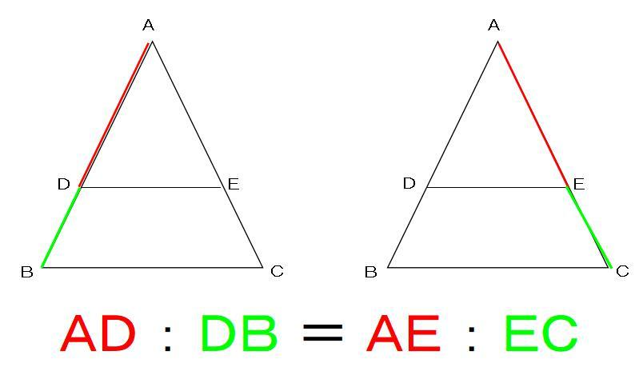
This relationship is fundamental to:
- Similarity.
- Proportionality.
- The Triangle Proportionality Theorem.
- Coordinate geometry.

Parallelism and Similarity
# Source: AI Source: Provided by: [Data Path: Persons Table -> ID Column: 1, Name_En Column: Motasem Essam] -> From: [ChatGPT] on [7/25/2026]
Parallel lines can create similar figures.
For example, in a triangle:
$$DE∥BC$$
then:
$$\boxed{△ADE∼△ABC}$$
under the appropriate configuration.
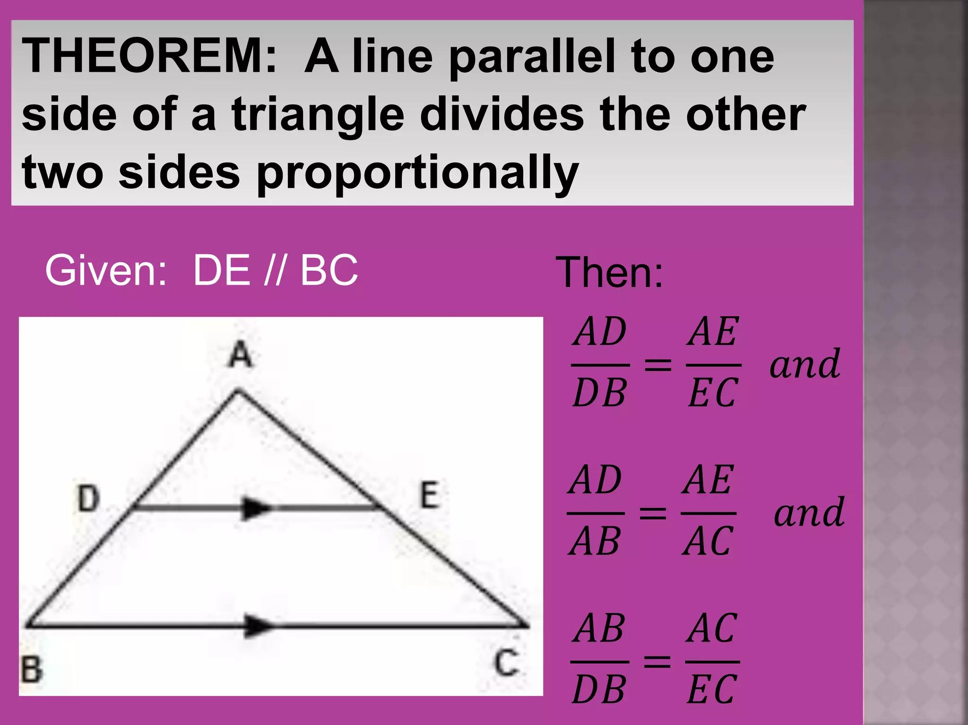
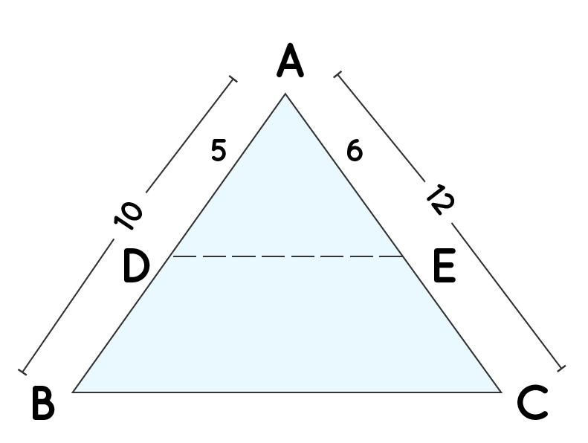
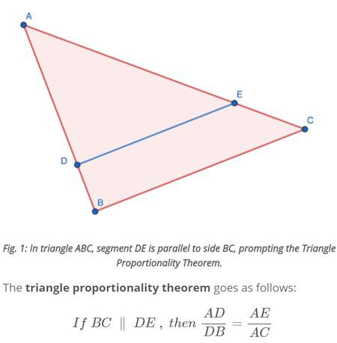
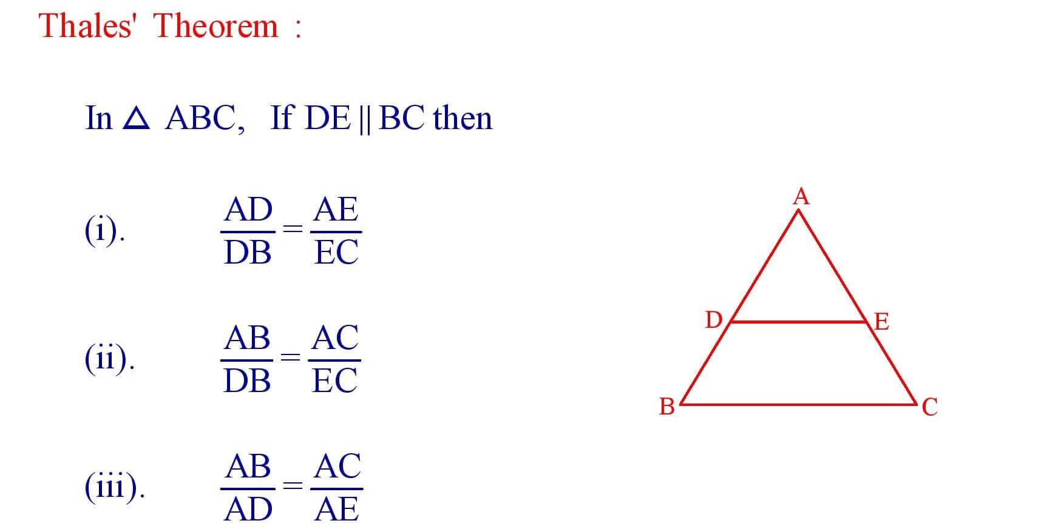

Parallelism in Architecture
# Source: AI Source: Provided by: [Data Path: Persons Table -> ID Column: 1, Name_En Column: Motasem Essam] -> From: [ChatGPT] on [7/25/2026]
Parallelism is widely used in architecture.
Examples include:
- Walls.
- Floors.
- Ceilings.
- Windows.
- Beams.
- Columns.
- Building edges.

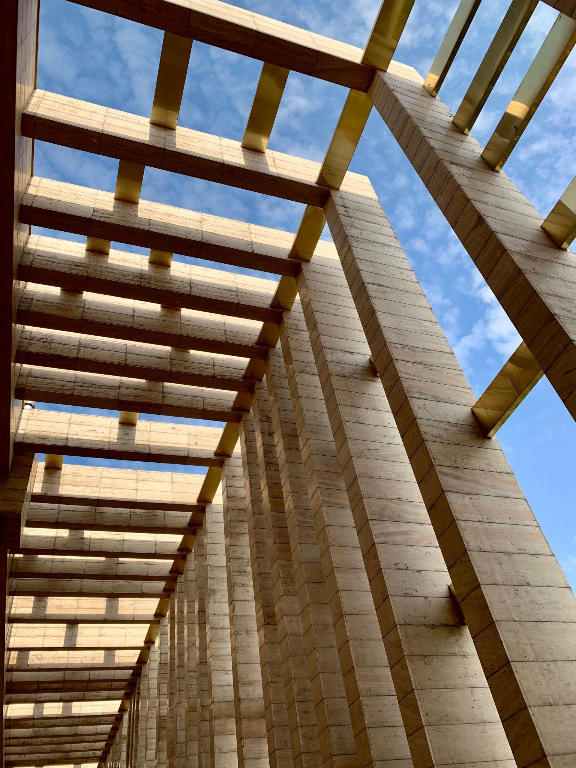

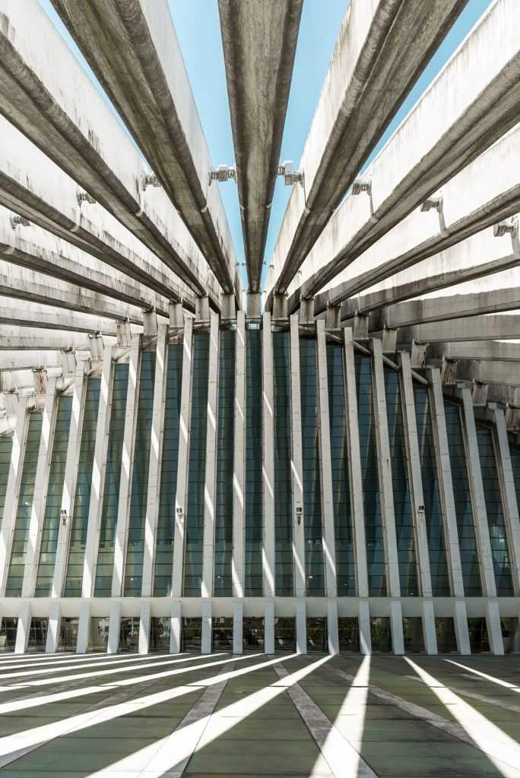
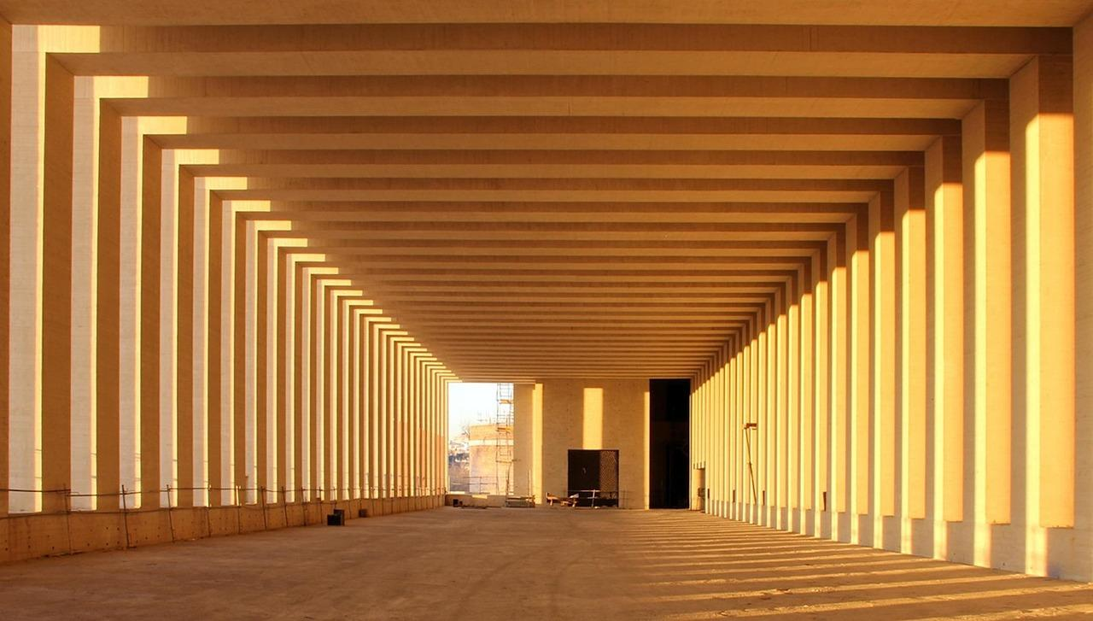
Parallel construction helps create organized and structurally consistent designs.

Parallelism in Engineering
# Source: AI Source: Provided by: [Data Path: Persons Table -> ID Column: 1, Name_En Column: Motasem Essam] -> From: [ChatGPT] on [7/25/2026]
Engineers use parallel relationships in:
- Mechanical components.
- Rails.
- Structural beams.
- Machine parts.
- Bridges.
- Manufacturing.
- Technical drawings.
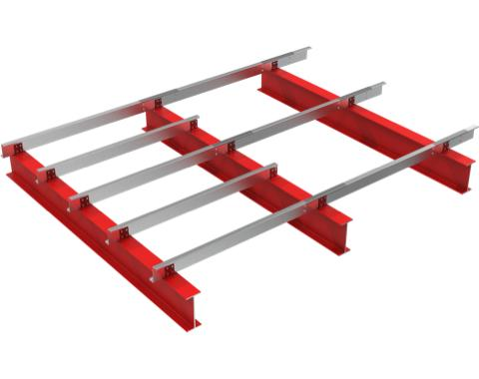
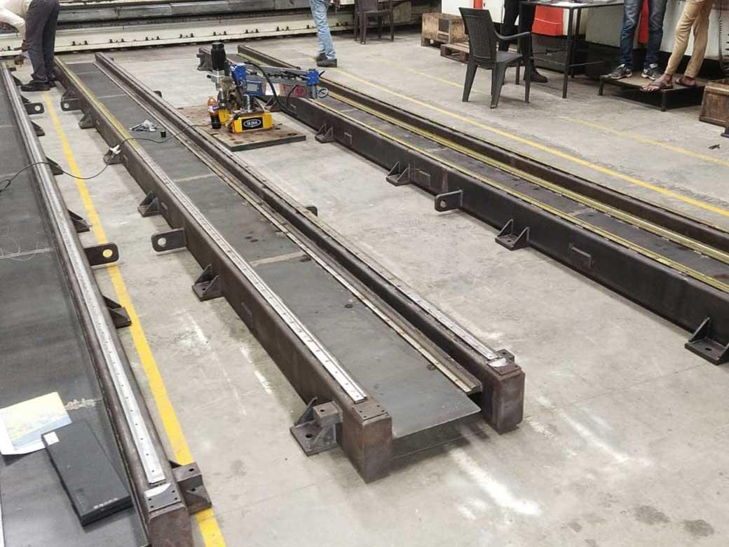
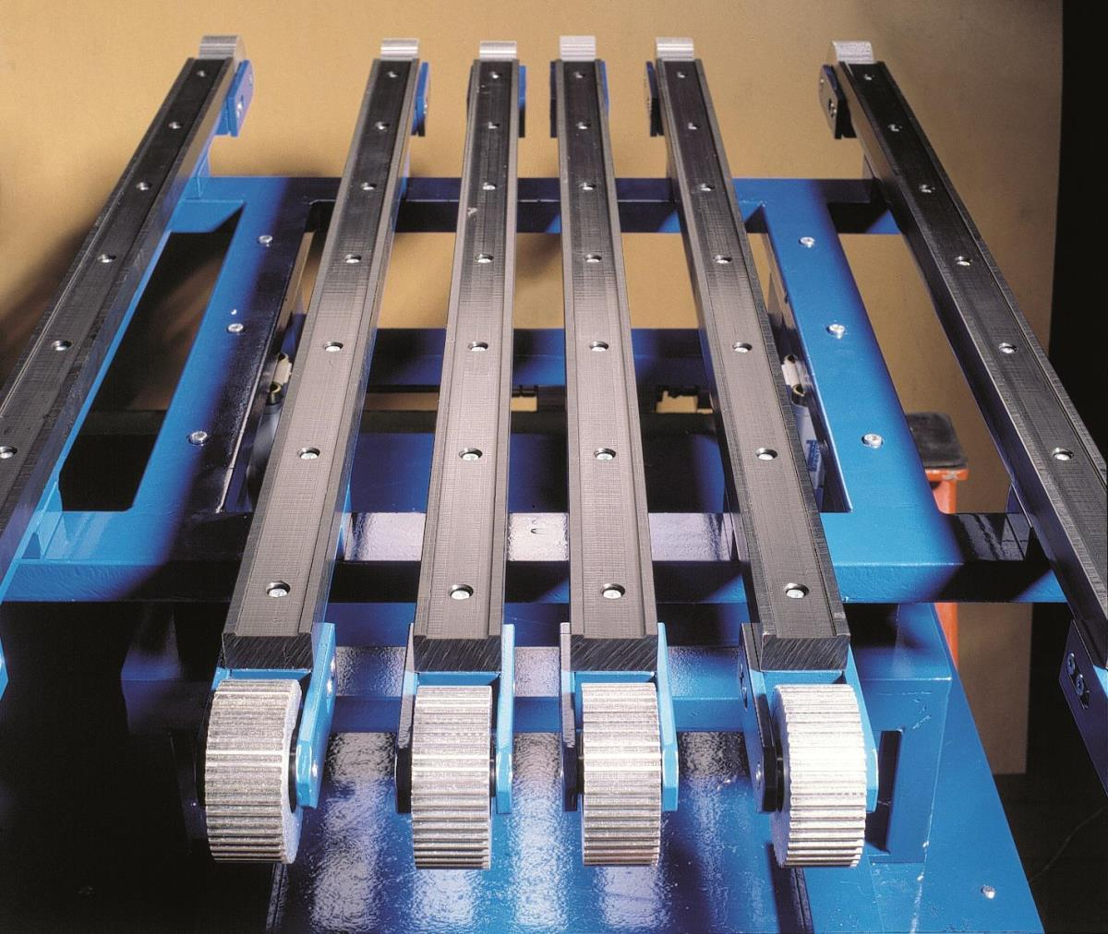

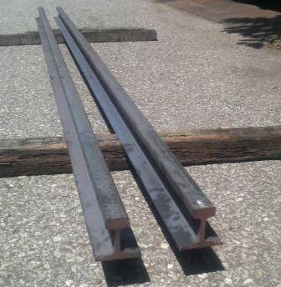
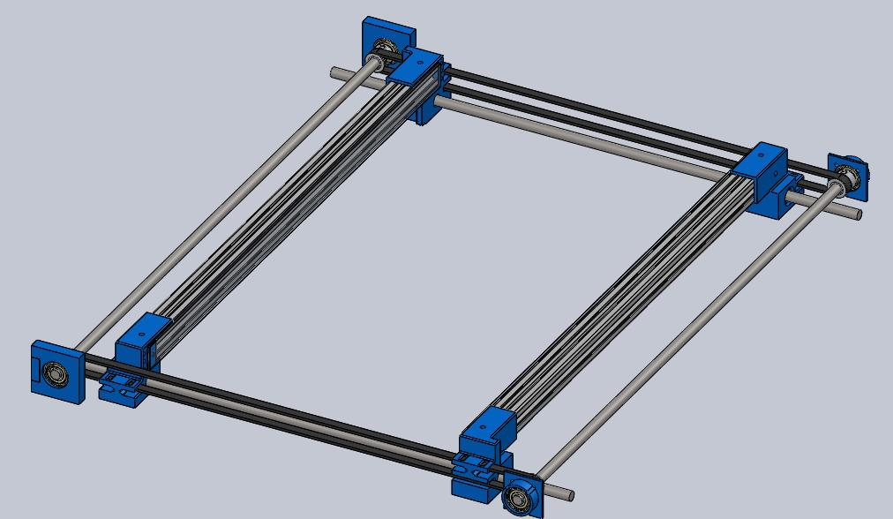

Parallelism in CAD
# Source: AI Source: Provided by: [Data Path: Persons Table -> ID Column: 1, Name_En Column: Motasem Essam] -> From: [ChatGPT] on [7/25/2026]
Computer-Aided Design (CAD) systems allow designers to create objects with exact parallel relationships.
For example:
$$\boxed{\text{Line A}∥\text{Line B}}$$
can be imposed as a geometric constraint.
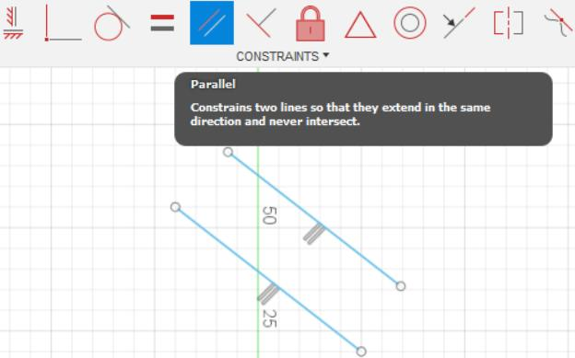
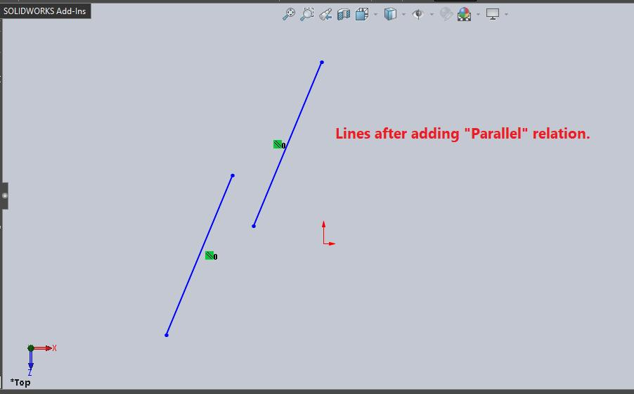
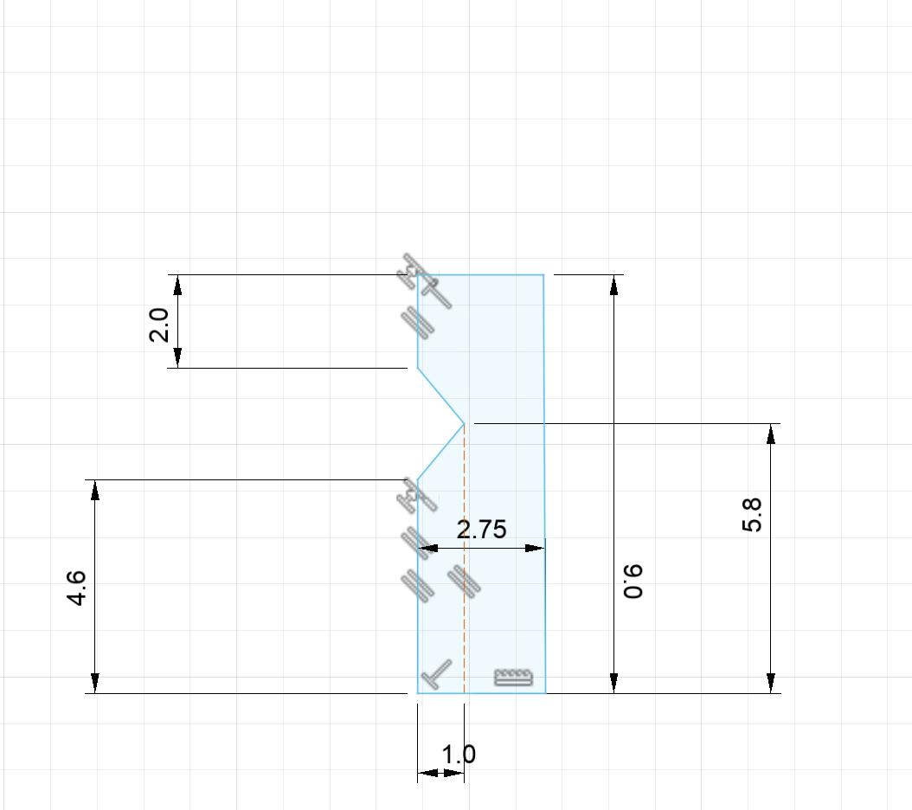
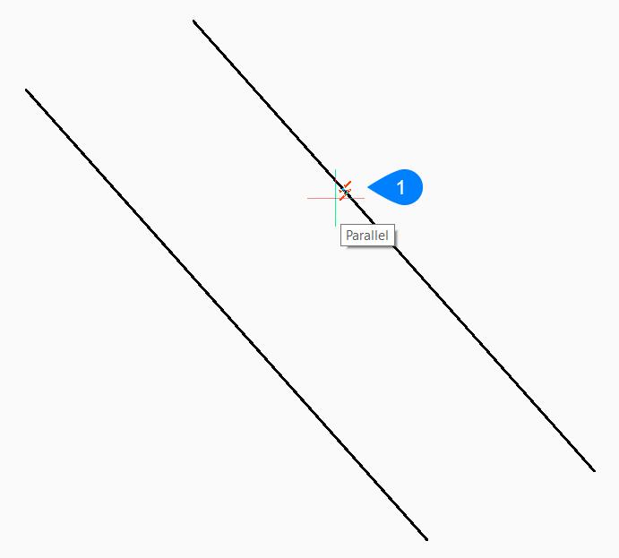
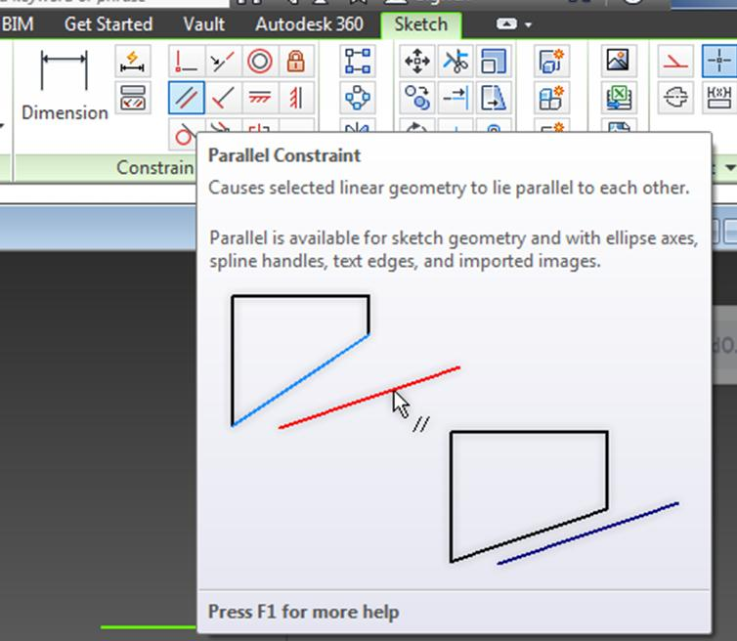

Parallelism in Real Life
# Source: AI Source: Provided by: [Data Path: Persons Table -> ID Column: 1, Name_En Column: Motasem Essam] -> From: [ChatGPT] on [7/25/2026]
Examples of approximately parallel lines include:
- Railway tracks.
- Lanes on a road.
- Opposite edges of a ruler.
- Lines on ruled paper.
- Building walls.
- Window edges.
- Shelves.
- Fences.






Applications
# Source: AI Source: Provided by: [Data Path: Persons Table -> ID Column: 1, Name_En Column: Motasem Essam] -> From: [ChatGPT] on [7/25/2026]
Parallelism is important in:
- Plane Geometry
- Euclidean Geometry
- Coordinate Geometry
- Trigonometry
- Architecture
- Civil Engineering
- Mechanical Engineering
- CAD
- Surveying
- Cartography
- Computer Graphics
- Construction

Advantages
# Source: AI Source: Provided by: [Data Path: Persons Table -> ID Column: 1, Name_En Column: Motasem Essam] -> From: [ChatGPT] on [7/25/2026]
Studying parallelism helps to:
- Analyze geometric relationships.
- Calculate unknown angles.
- Identify geometric properties.
- Prove geometric theorems.
- Construct accurate figures.
- Understand similarity.
- Analyze coordinate graphs.
- Create precise engineering designs.
- Improve accuracy in architecture and CAD.

Limitations
# Source: AI Source: Provided by: [Data Path: Persons Table -> ID Column: 1, Name_En Column: Motasem Essam] -> From: [ChatGPT] on [7/25/2026]
Parallelism:
- In plane geometry, applies to lines that lie in the same plane.
- Does not mean that two lines have equal lengths.
- Does not mean that two line segments must be the same size.
- Can be difficult to identify in distorted drawings.
- In three-dimensional geometry, the relationship between lines becomes more complex because lines can also be skew lines.

Comparison with Related Concepts
# Source: AI Source: Provided by: [Data Path: Persons Table -> ID Column: 1, Name_En Column: Motasem Essam] -> From: [ChatGPT] on [7/25/2026]
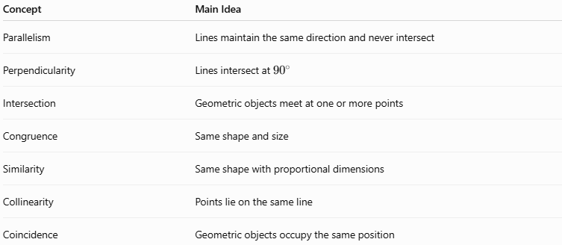
Concept | Main Idea
Parallelism | Lines maintain the same direction and never intersect
Perpendicularity | Lines intersect at ${90}^{∘}$
Intersection | Geometric objects meet at one or more points
Congruence | Same shape and size
Similarity | Same shape with proportional dimensions
Collinearity | Points lie on the same line
Coincidence | Geometric objects occupy the same position

Key Points
# Source: AI Source: Provided by: [Data Path: Persons Table -> ID Column: 1, Name_En Column: Motasem Essam] -> From: [ChatGPT] on [7/25/2026]
- Parallelism is a geometric relationship between lines or other geometric objects.
- Parallel lines in a plane:
  - Never intersect.
  - Have the same direction.
  - Maintain a constant perpendicular distance.
- The symbol for parallelism is:
$$\boxed{∥}$$
- Two non-vertical coordinate lines are parallel when:
$$\boxed{m_{1}=m_{2}}$$
- Parallel lines crossed by a transversal produce important angle relationships.
- Corresponding angles are equal.
- Alternate interior angles are equal.
- Alternate exterior angles are equal.
- Same-side interior angles are supplementary:
$$\boxed{{180}^{∘}}$$
- Parallelism is an important property of parallelograms, rectangles, squares, and trapezoids.
- Parallel lines can create similar triangles.
- Parallelism is fundamental to geometry, architecture, engineering, surveying, CAD, and construction.

Conclusion
# Source: AI Source: Provided by: [Data Path: Persons Table -> ID Column: 1, Name_En Column: Motasem Essam] -> From: [ChatGPT] on [7/25/2026]
Parallelism is a fundamental type of Geometric Relationship in which two or more lines in the same plane have the same direction, maintain a constant distance from each other, and never intersect. It is represented by the symbol (\parallel). Parallelism plays an important role in the study of angles, transversals, polygons, triangles, similarity, coordinate geometry, and Euclidean geometry. It is also essential in practical fields such as architecture, engineering, construction, surveying, CAD, and technical design, where maintaining accurate parallel relationships is often necessary.

